**USING CLI AND TNT DRIVE TO ACCESS AMAZON SERVICES**

1. Enter the instance name

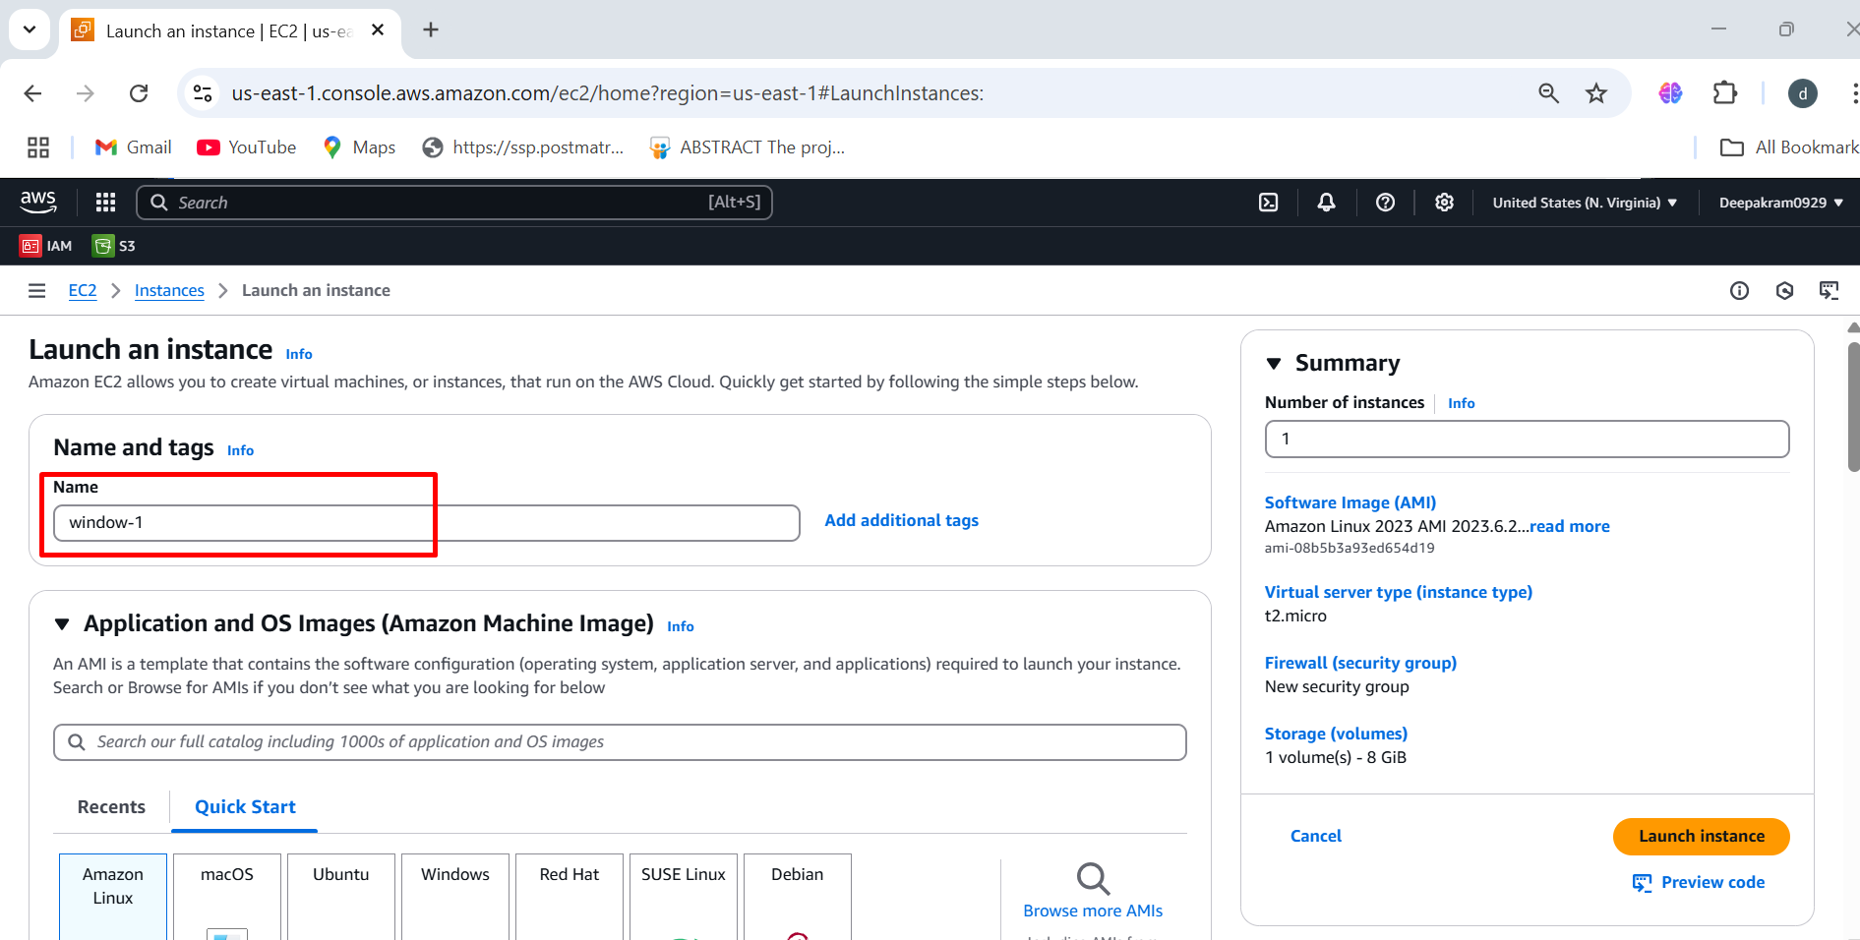

1. Choose the AMI 🡪 Windows server 2025 Base

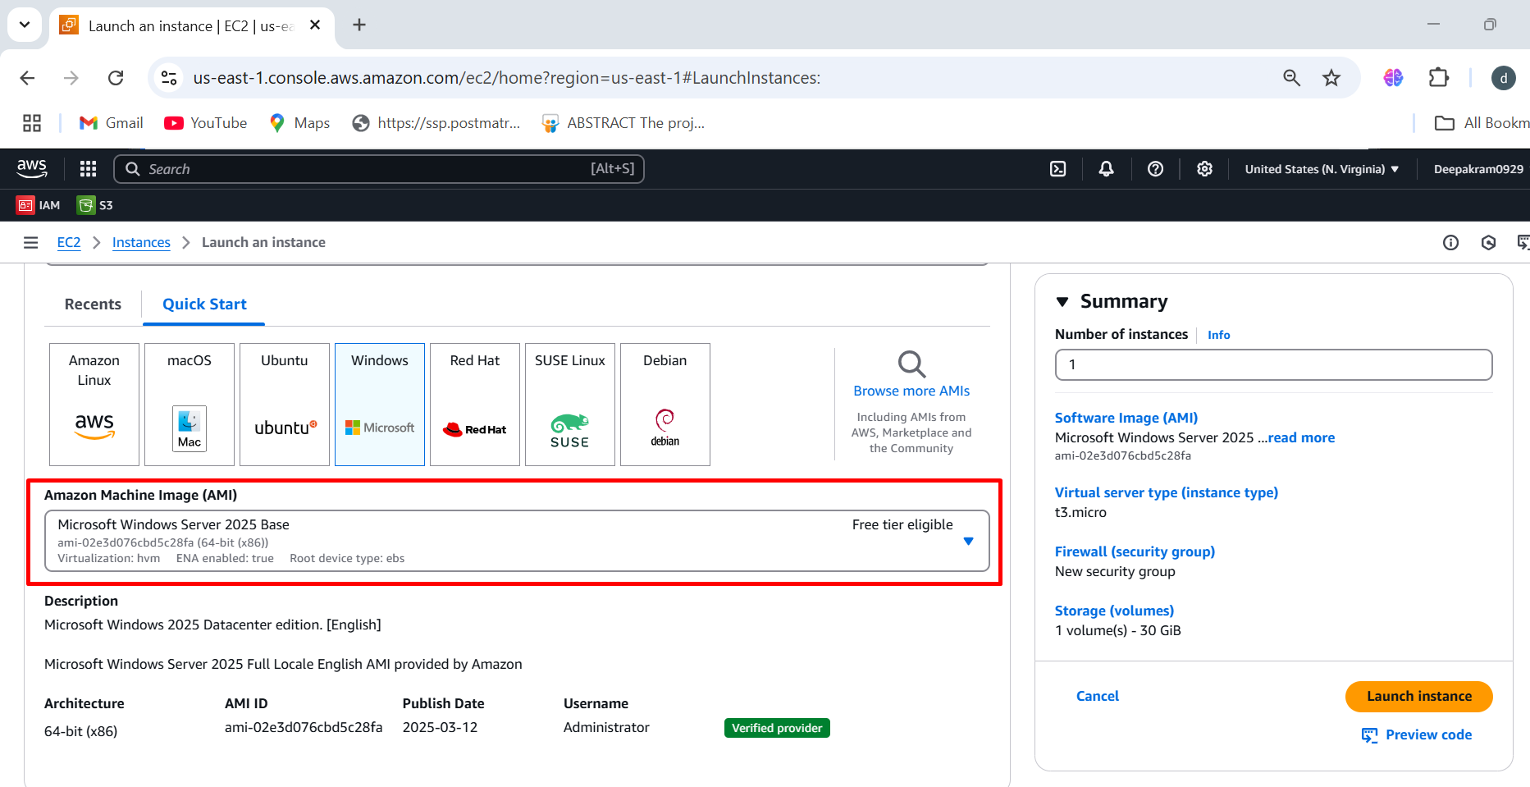

1. Select the instance type 🡪 t3.medium 🡪 keypair

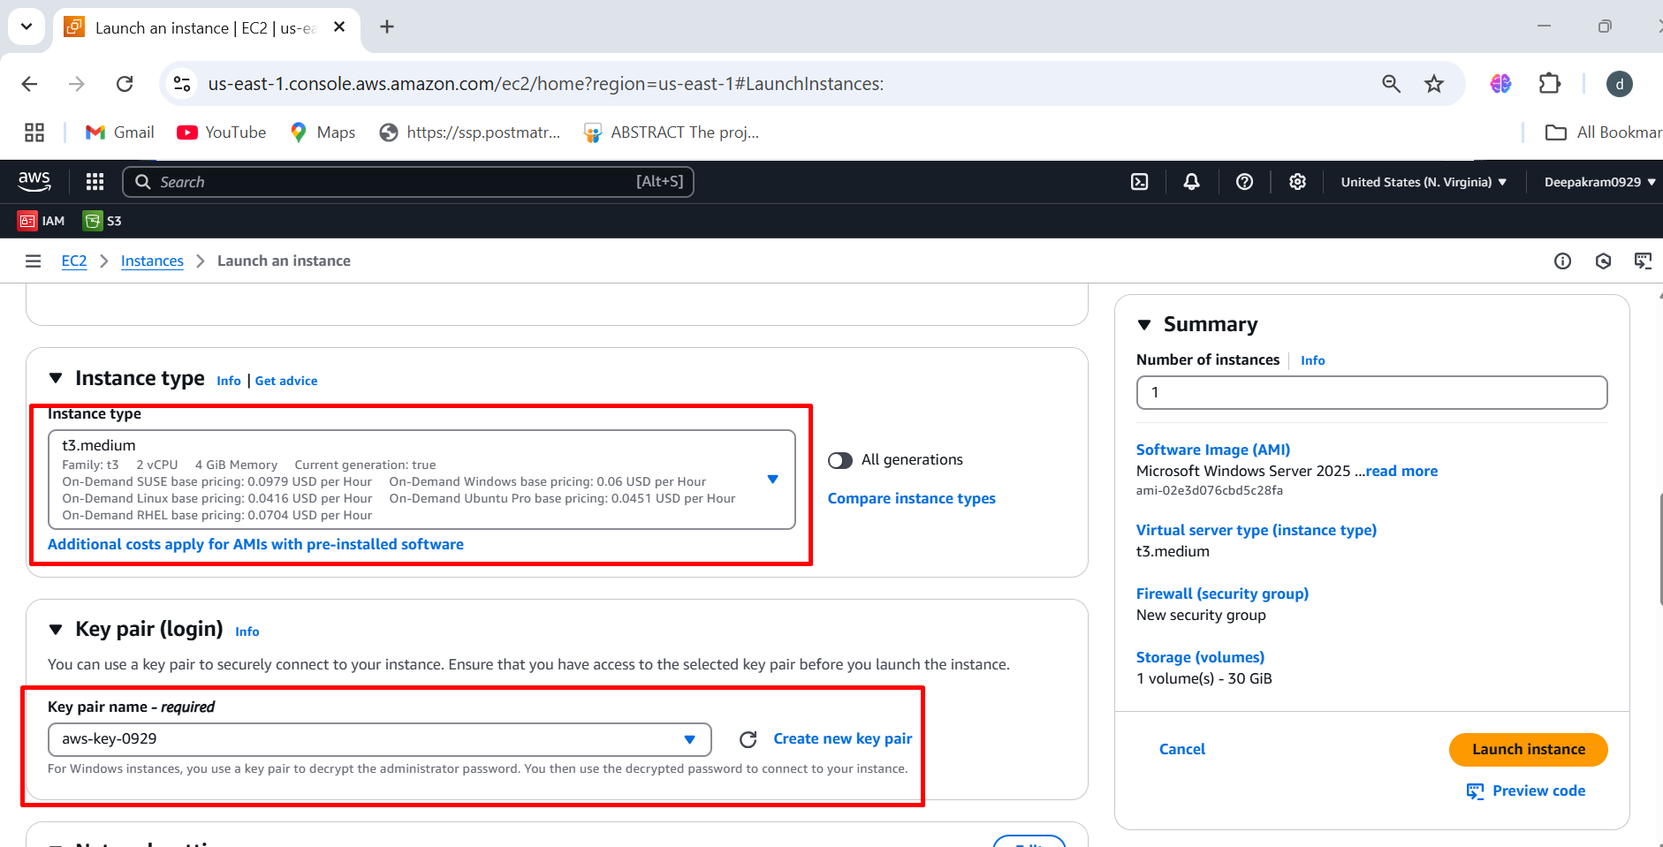

1. Select existing security group 🡪 windows-ssh-security 🡪 select the storage 🡪 launch instance

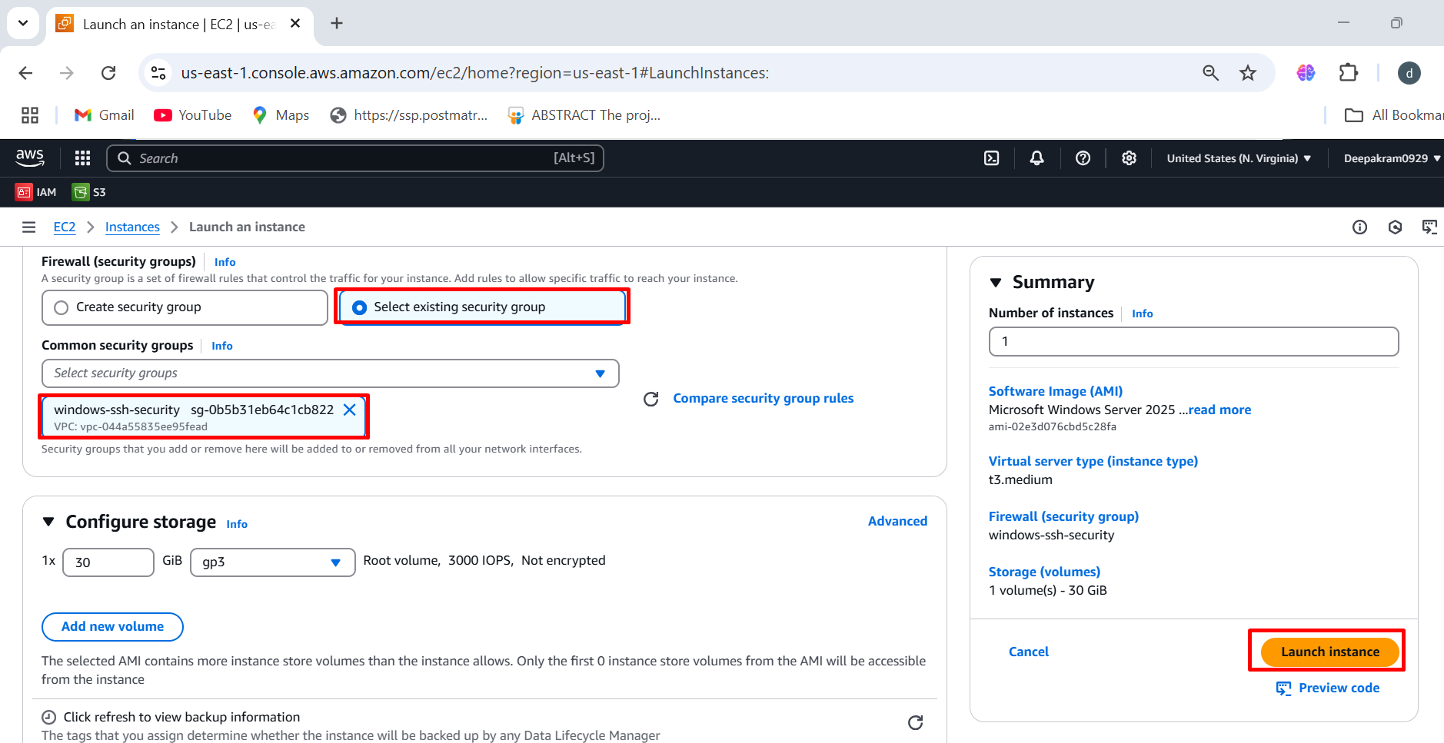

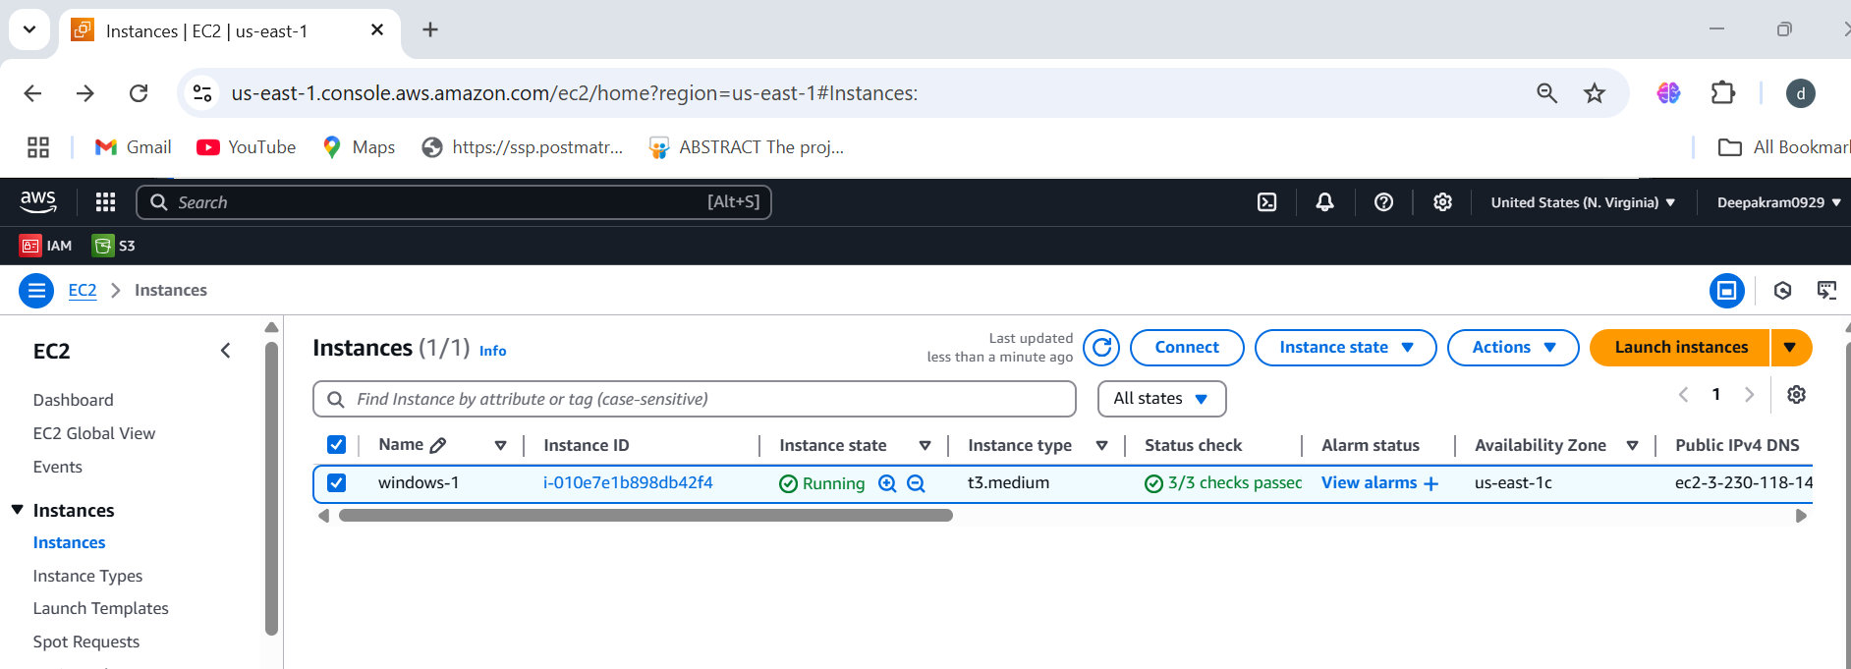

1. Under the RDP Client tab 🡪 Click Download Remote Desktop File 🡪 Click Get Password (if not already retrieved) 🡪 Upload your private key (.pem) file and click Decrypt Password 🡪 Copy the Administrator username and decrypted password.

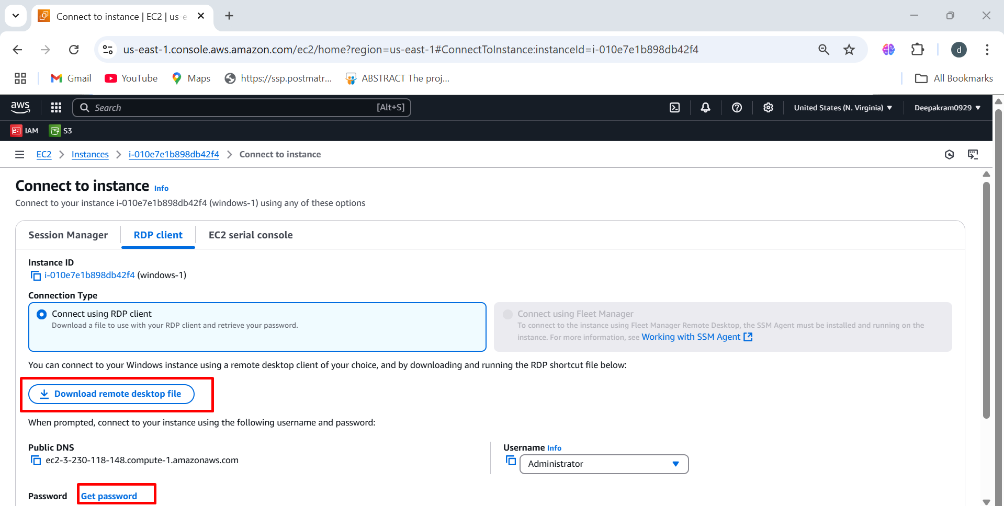

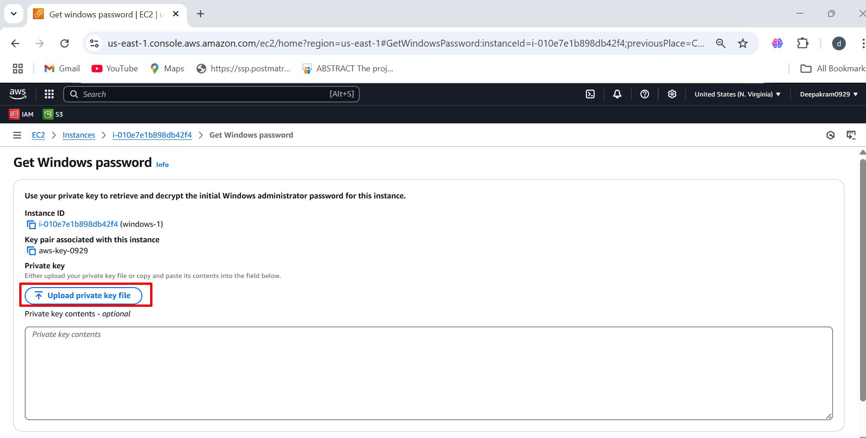

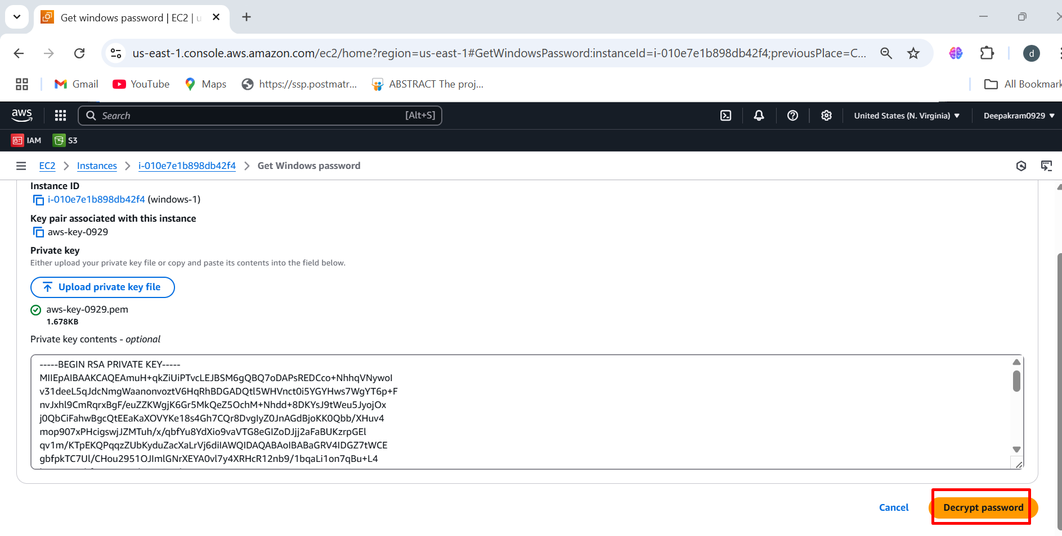

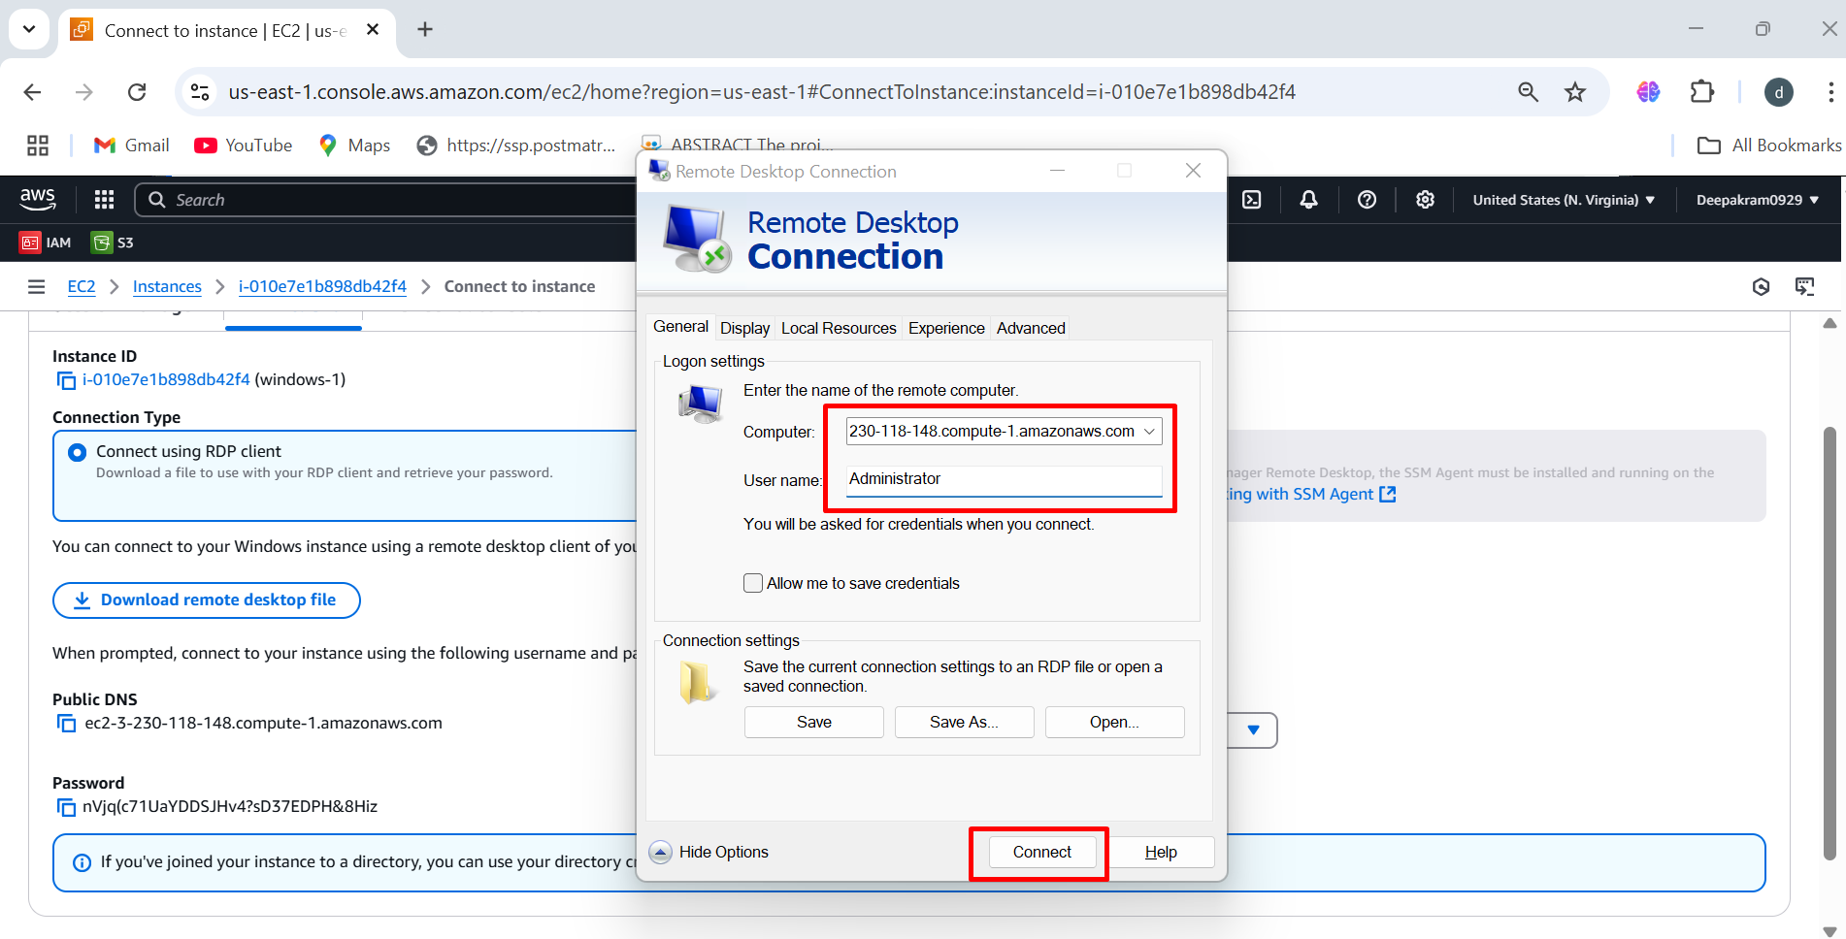

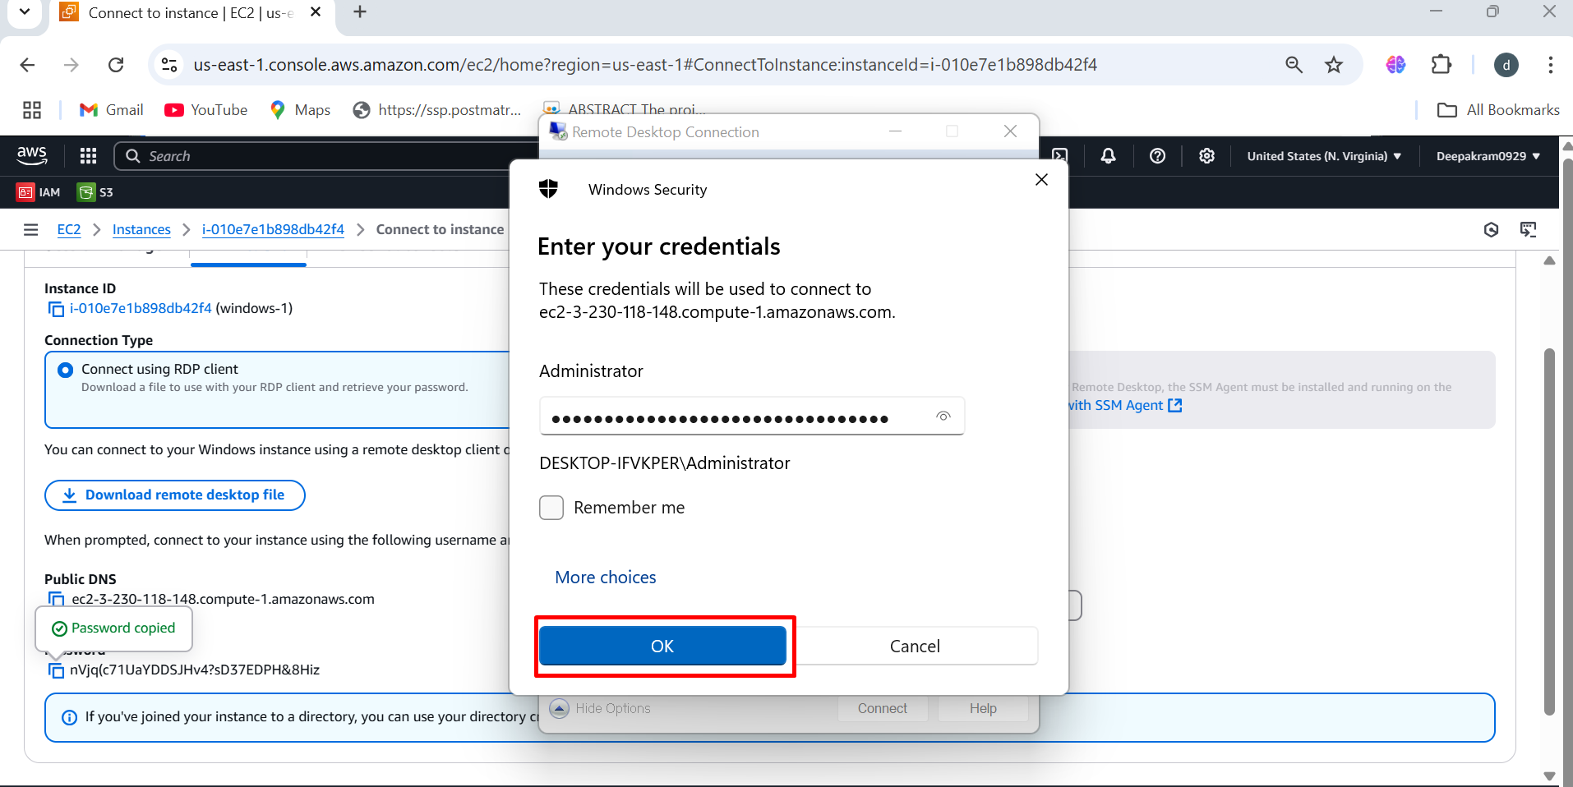

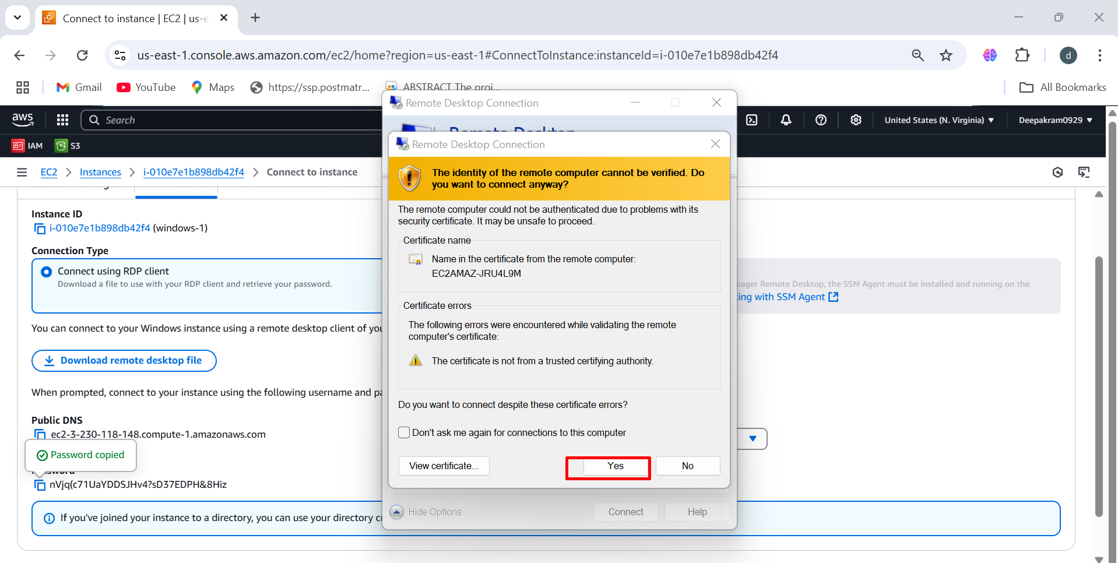

1. Connect To Virtual Window Servers

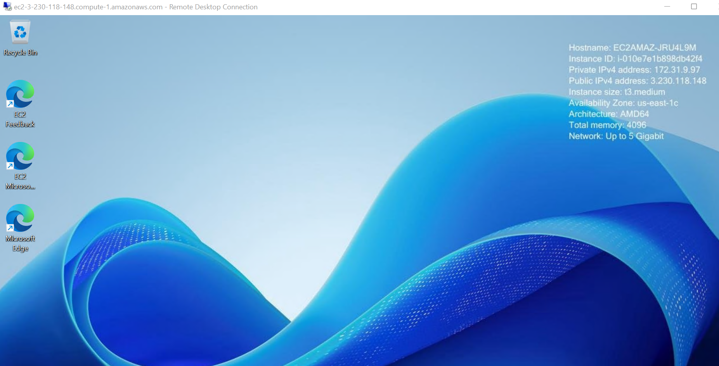

1. Download cli software in virtual window

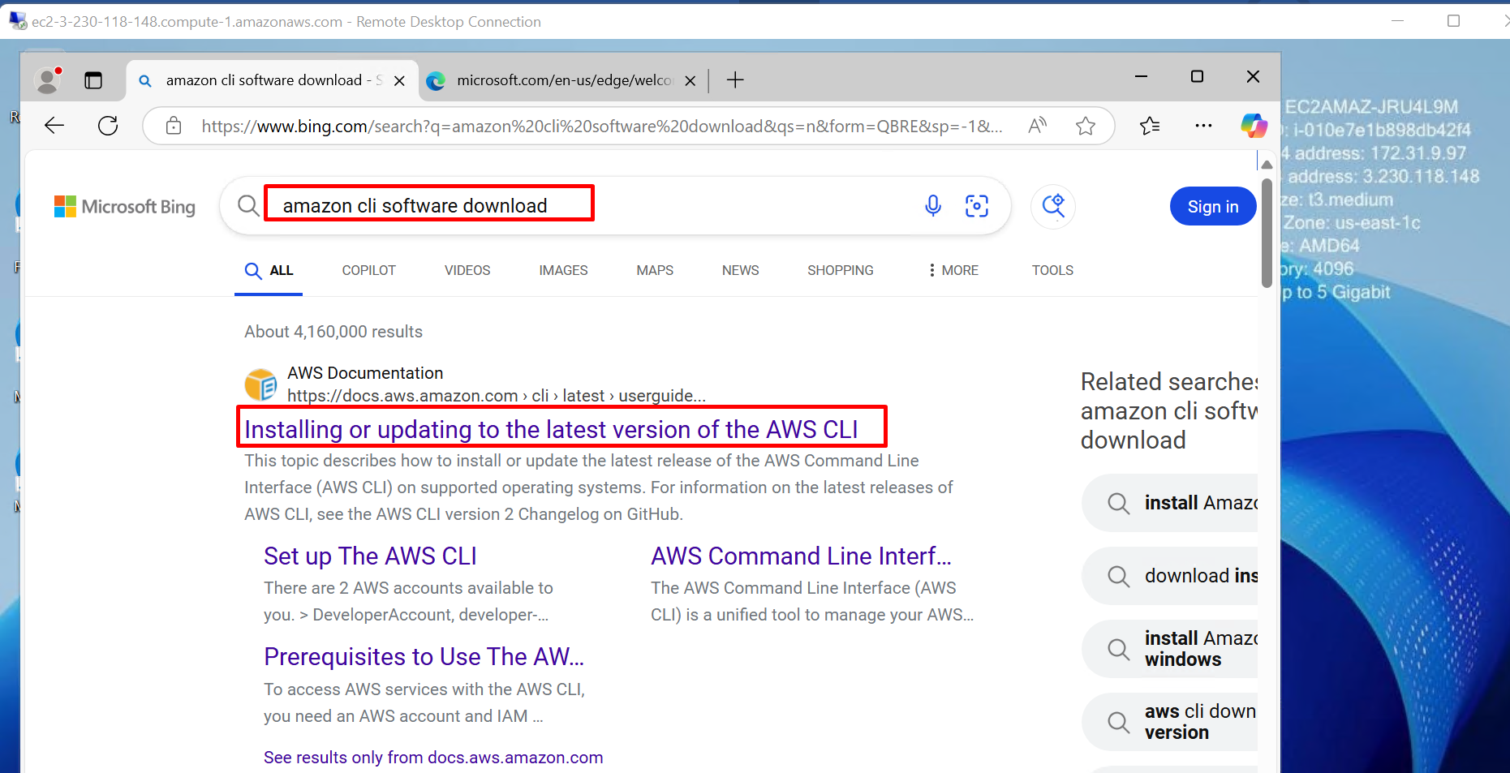

1. Click on windows 🡪 Click on aws cli msi installer for windows 64 bit

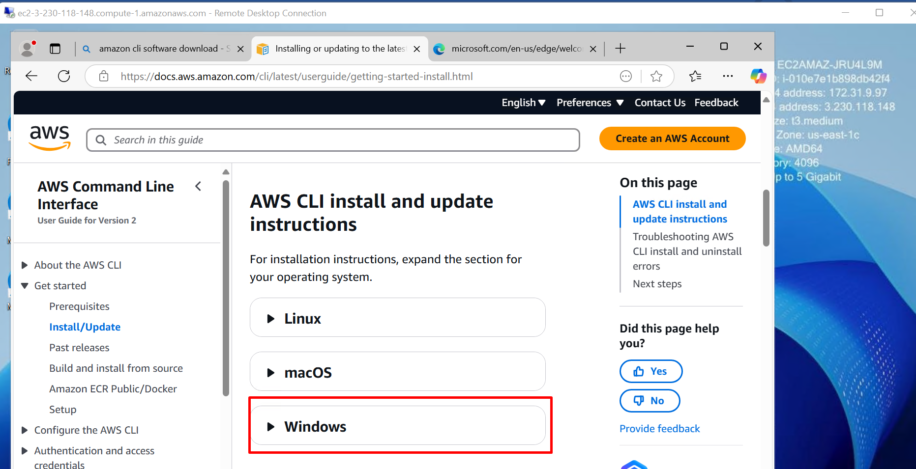

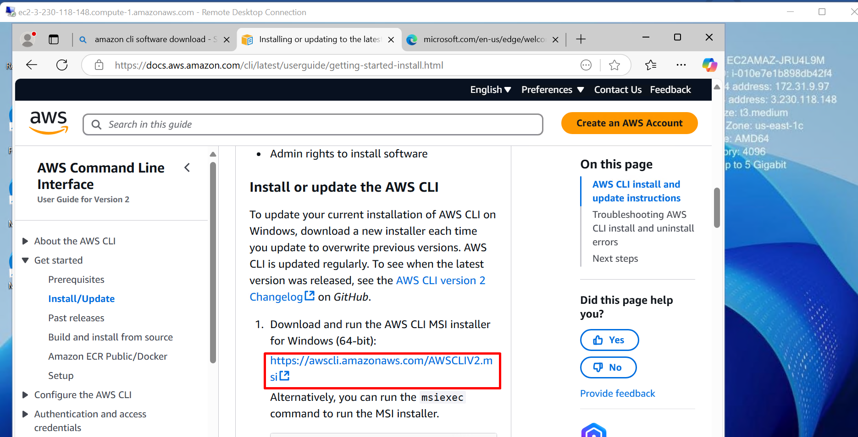

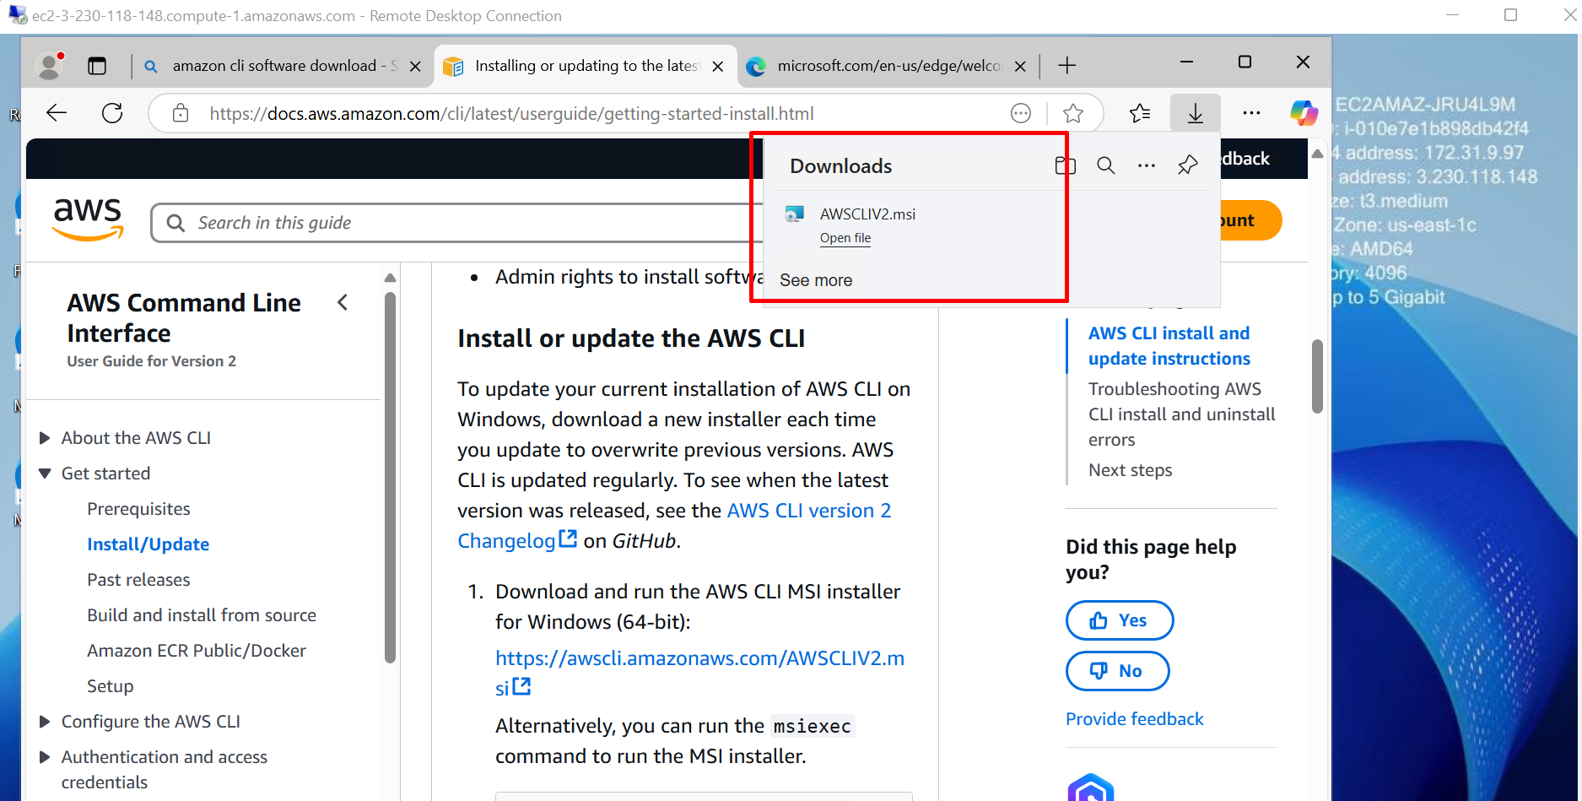

1. Setup the AWS command line interface

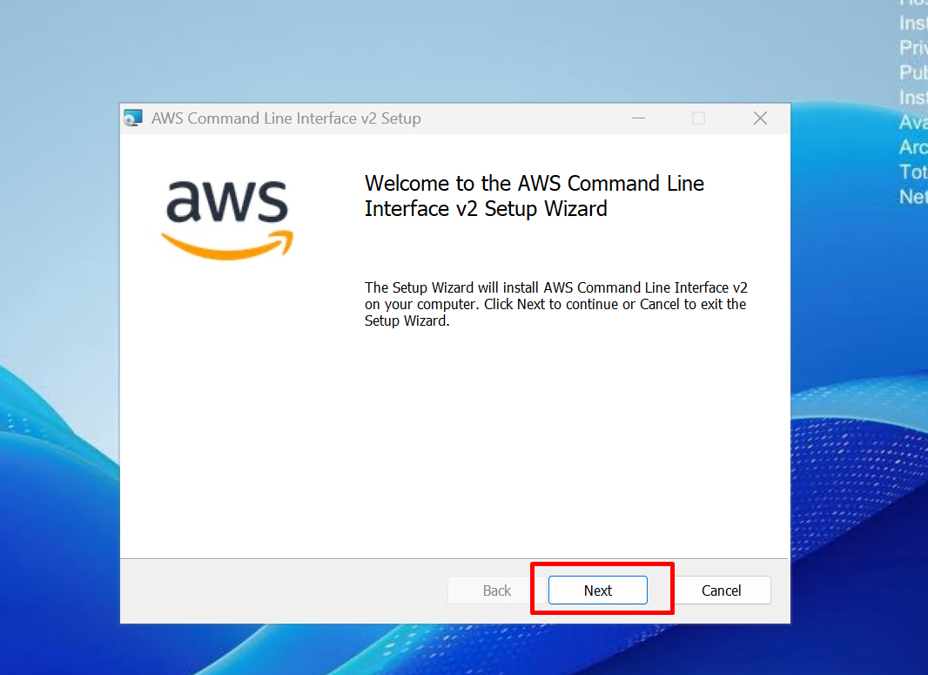

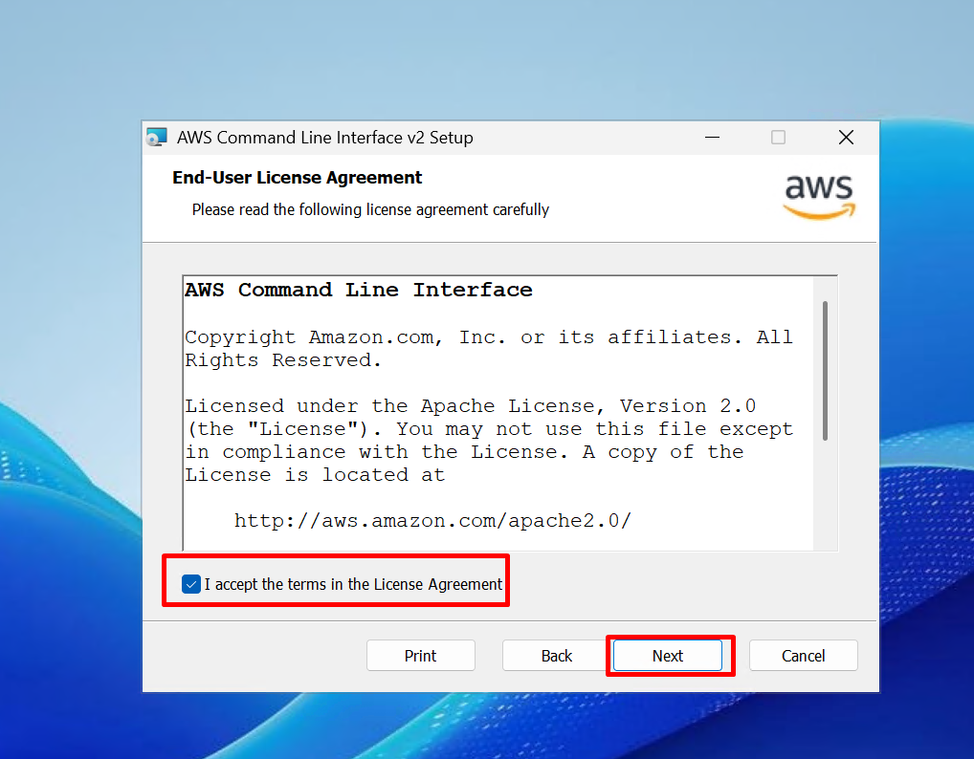

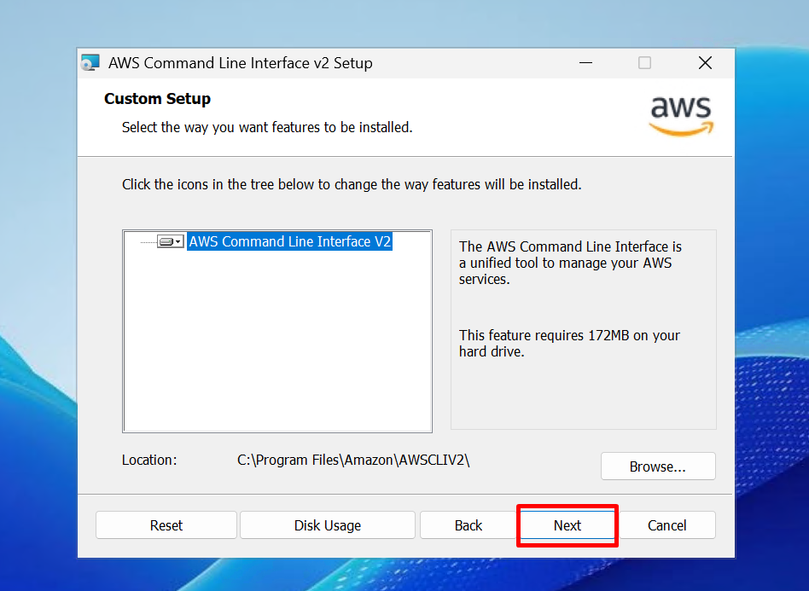

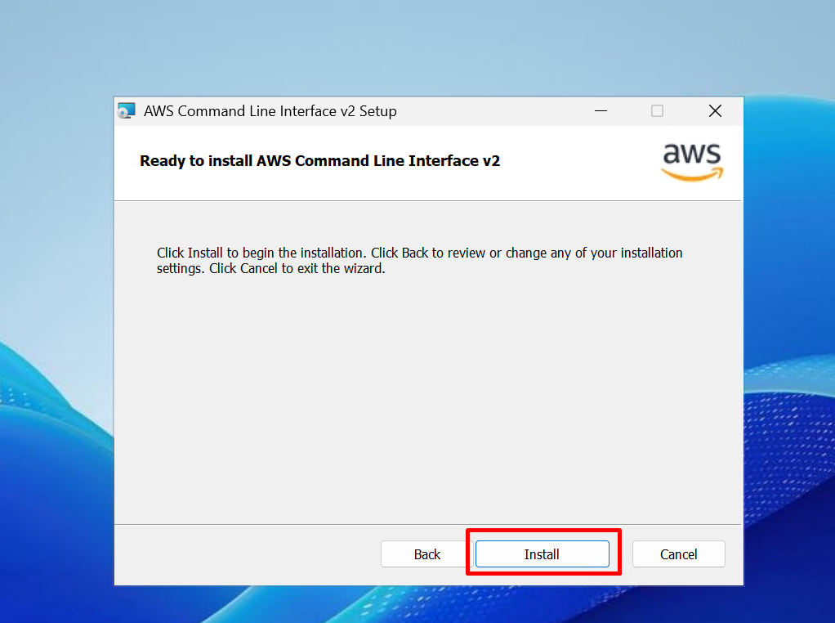

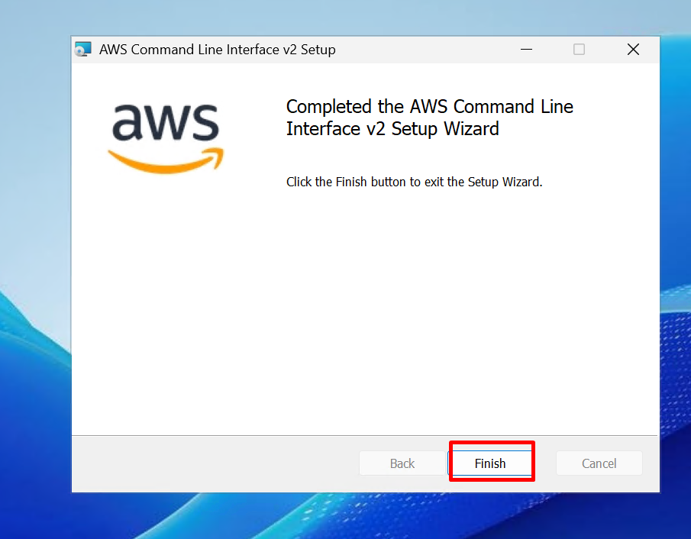

1. To check the CLI is installed 🡪 Open CMD 🡪 aws --version

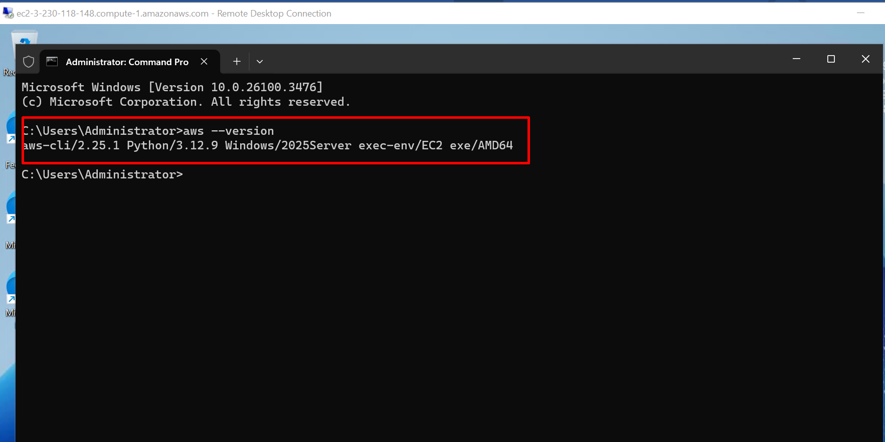

1. The **aws configure** command is used to set up AWS CLI (Command Line Interface) credentials and default settings, so you can interact with AWS services from the terminal.

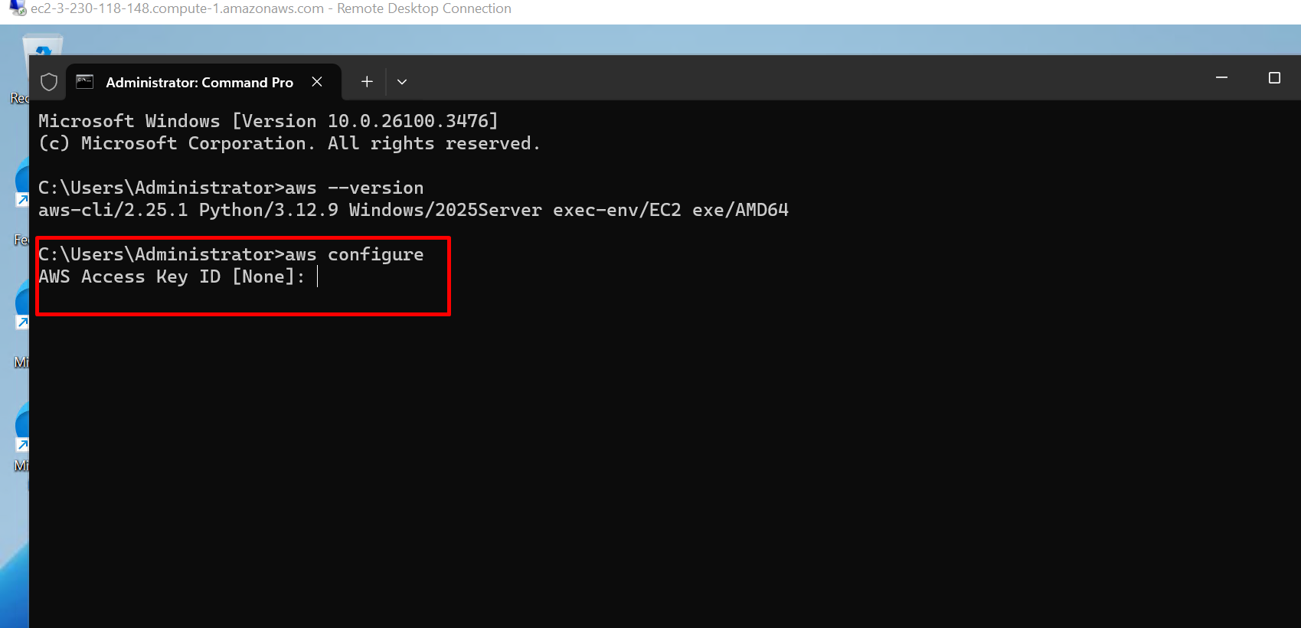

1. To create access key 🡪 account 🡪 security credentials

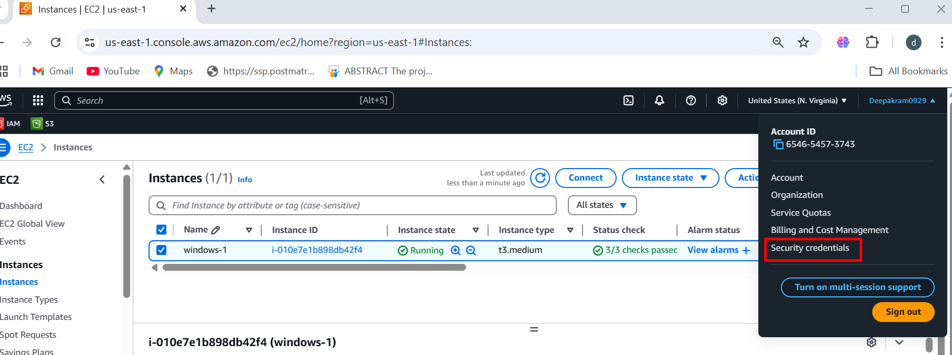

1. Click on create access key

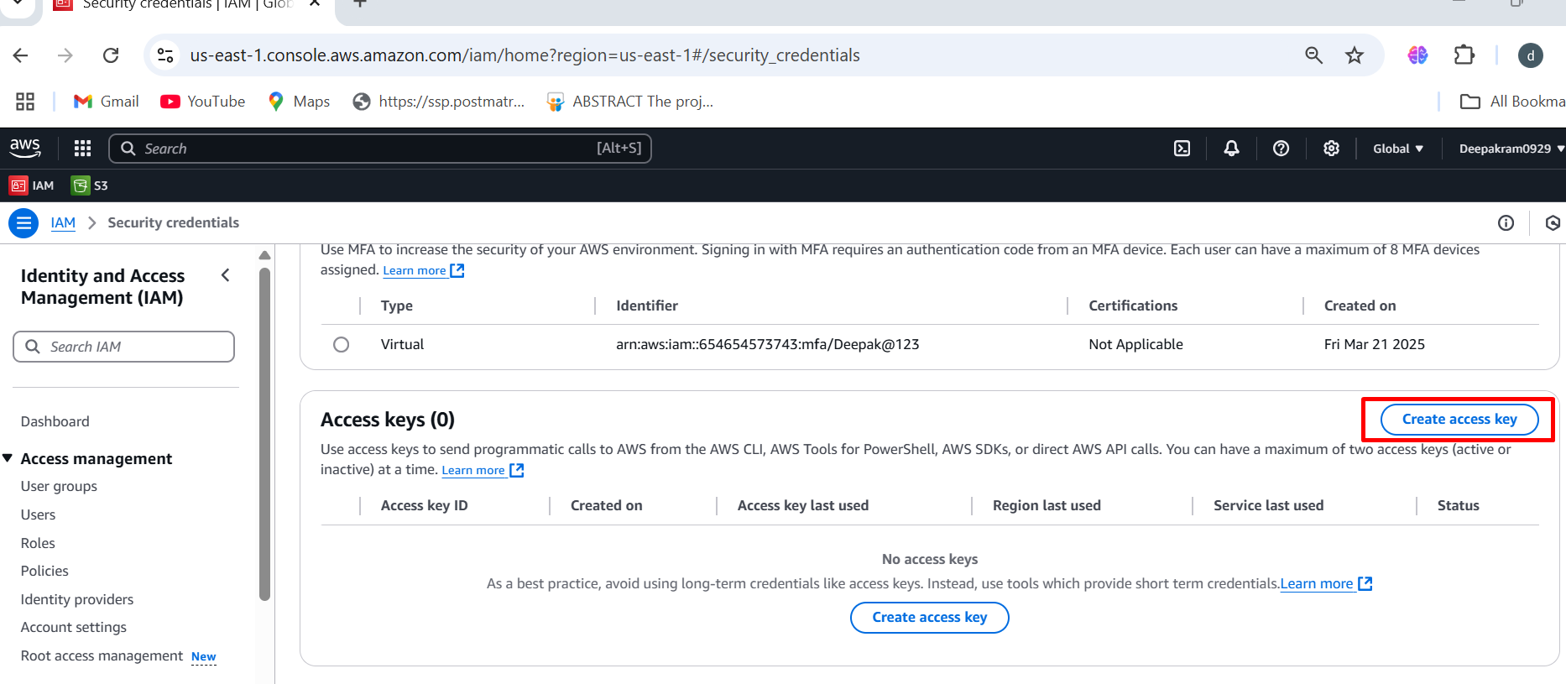

1. Access key and secret access key is created

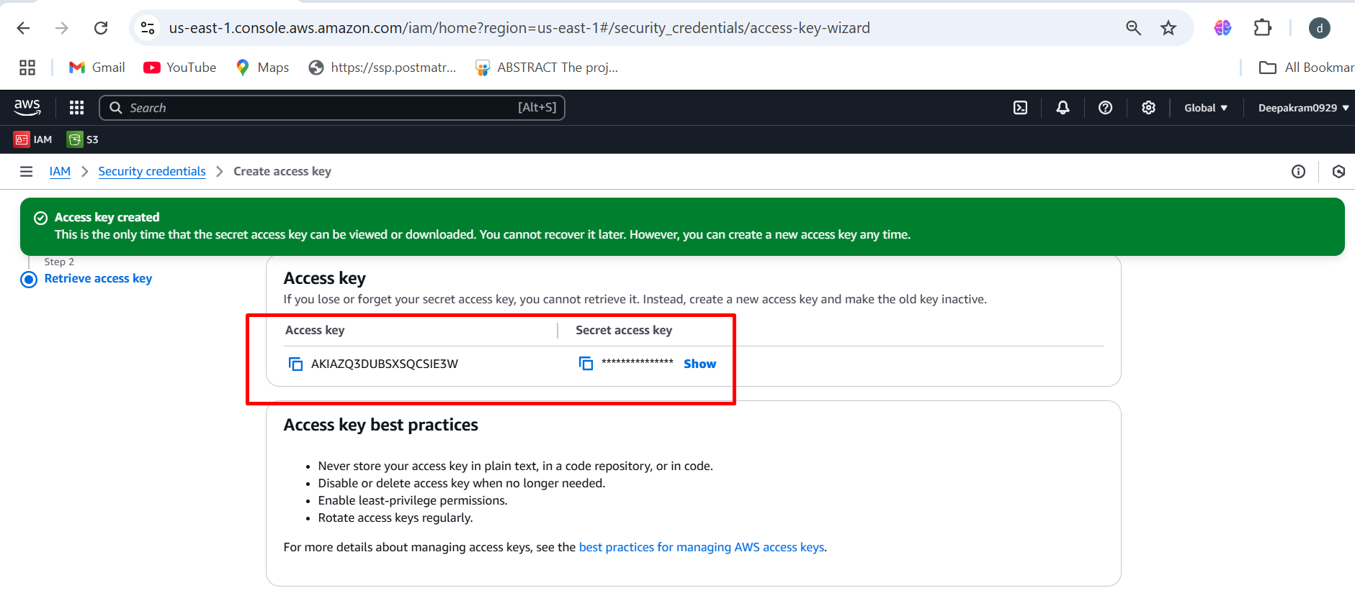

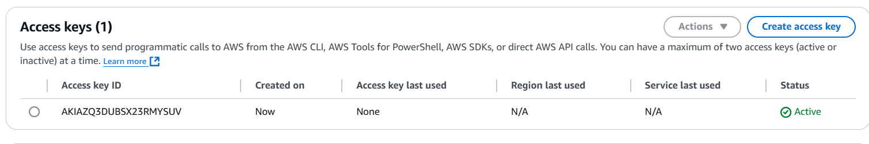

1. Enter the access key and secret access key 🡪 provide the region name 🡪 enter

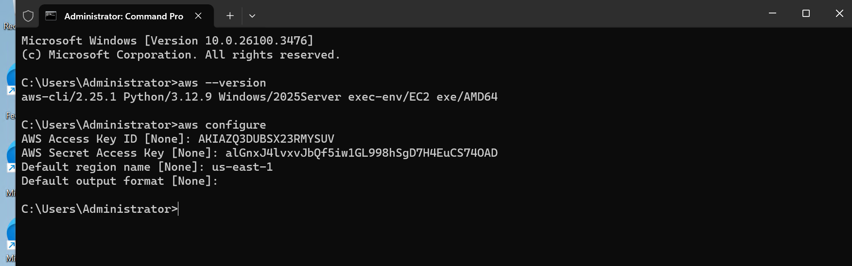

1. Create new bucket 🡪 unique name 🡪 6nov 🡪 create bucket

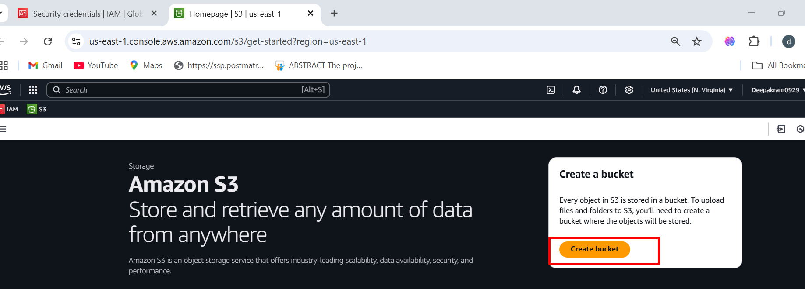

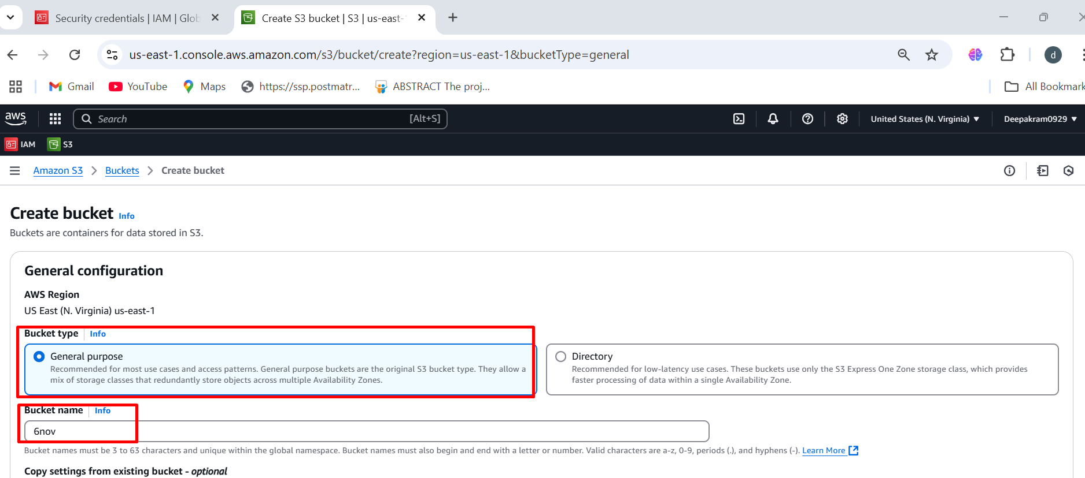

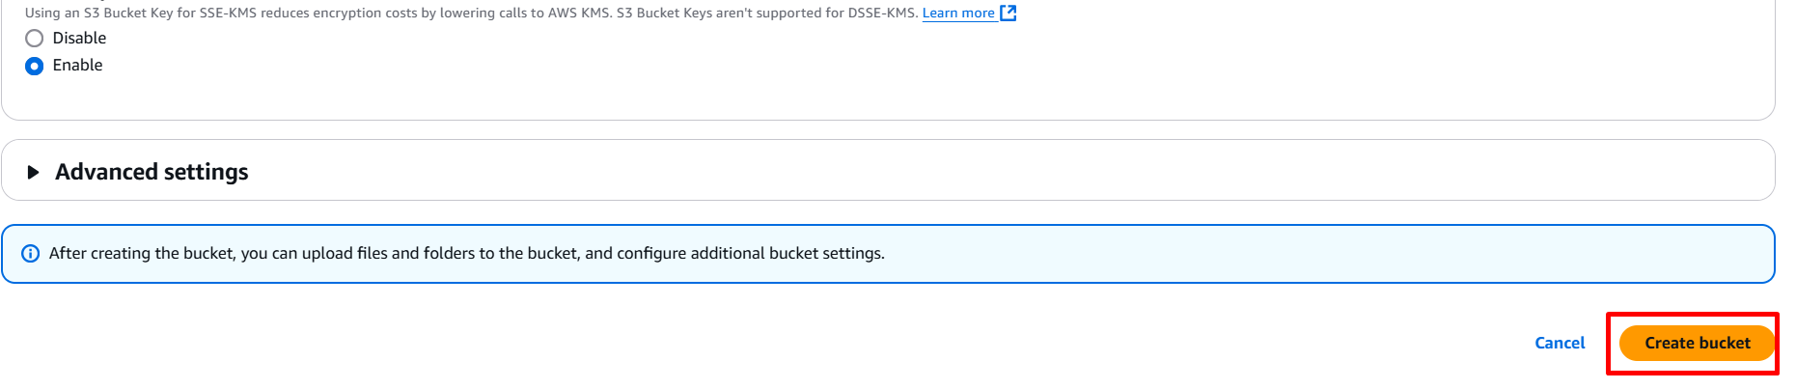

1. Now upload some files to bucket 🡪click on upload

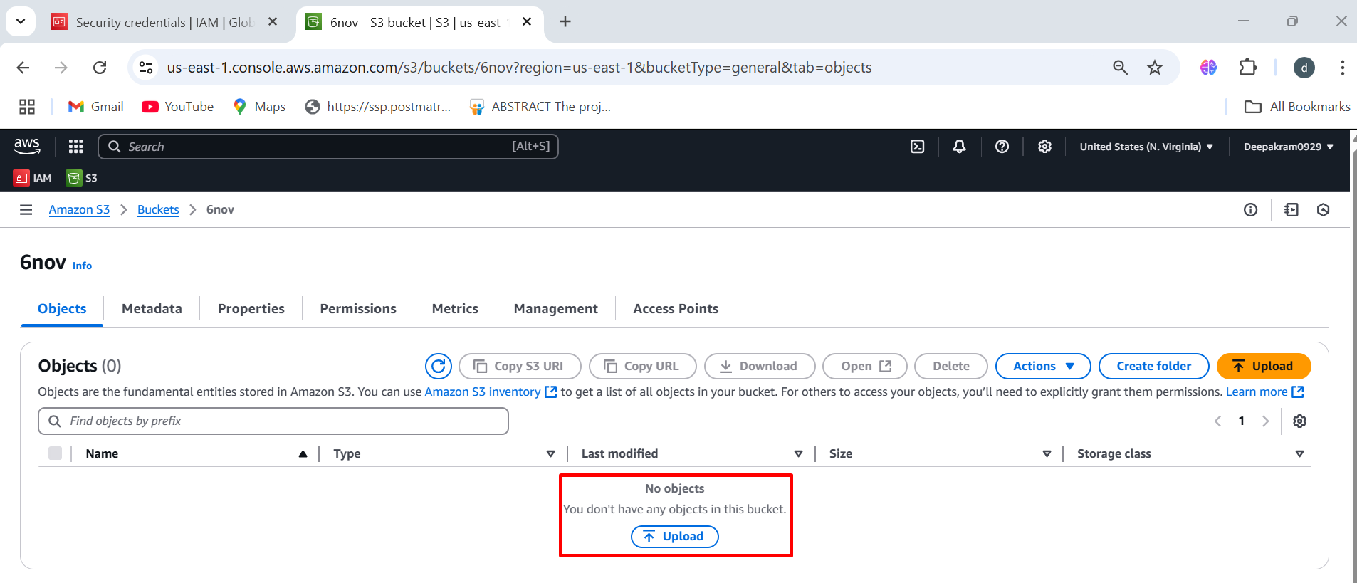

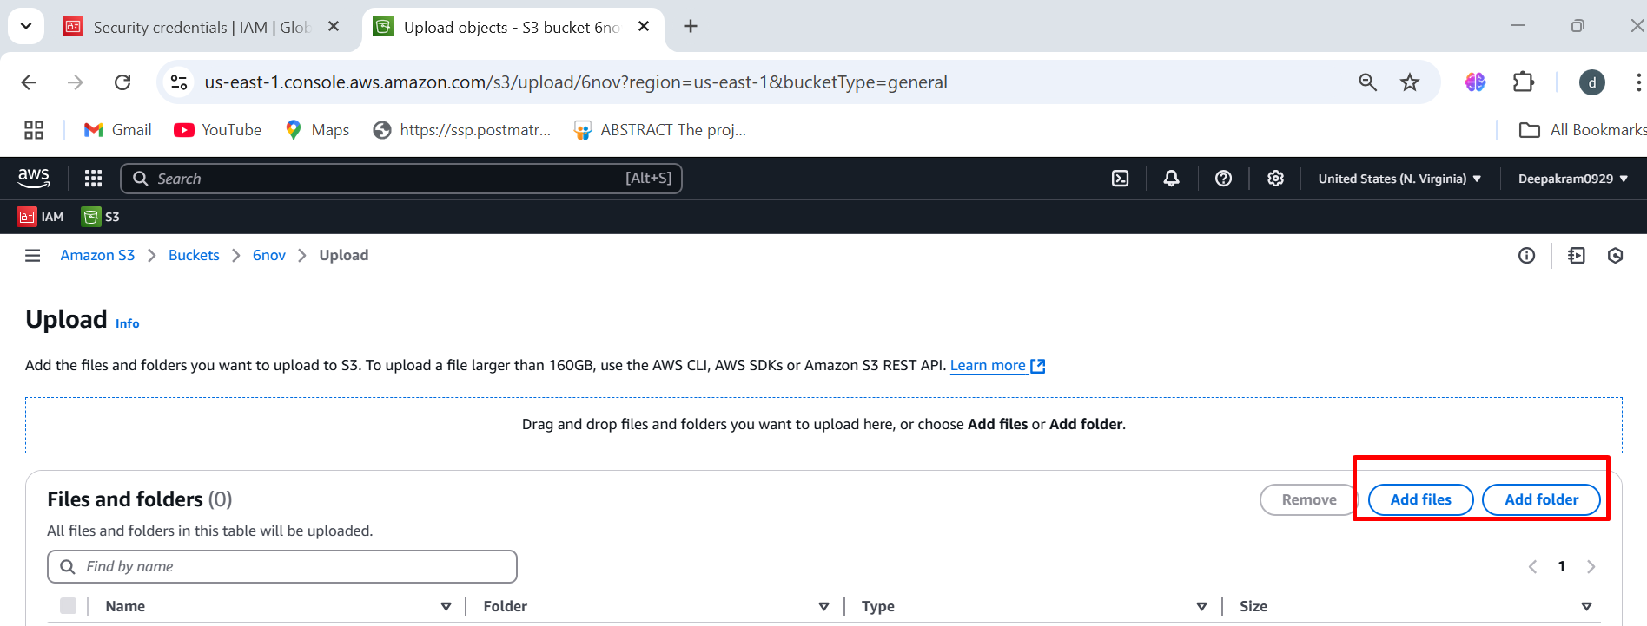

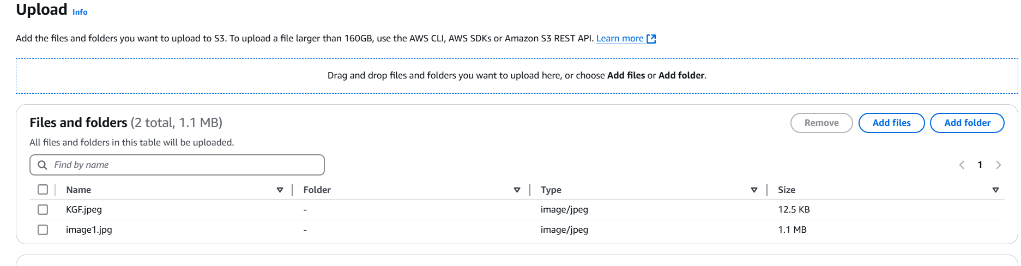

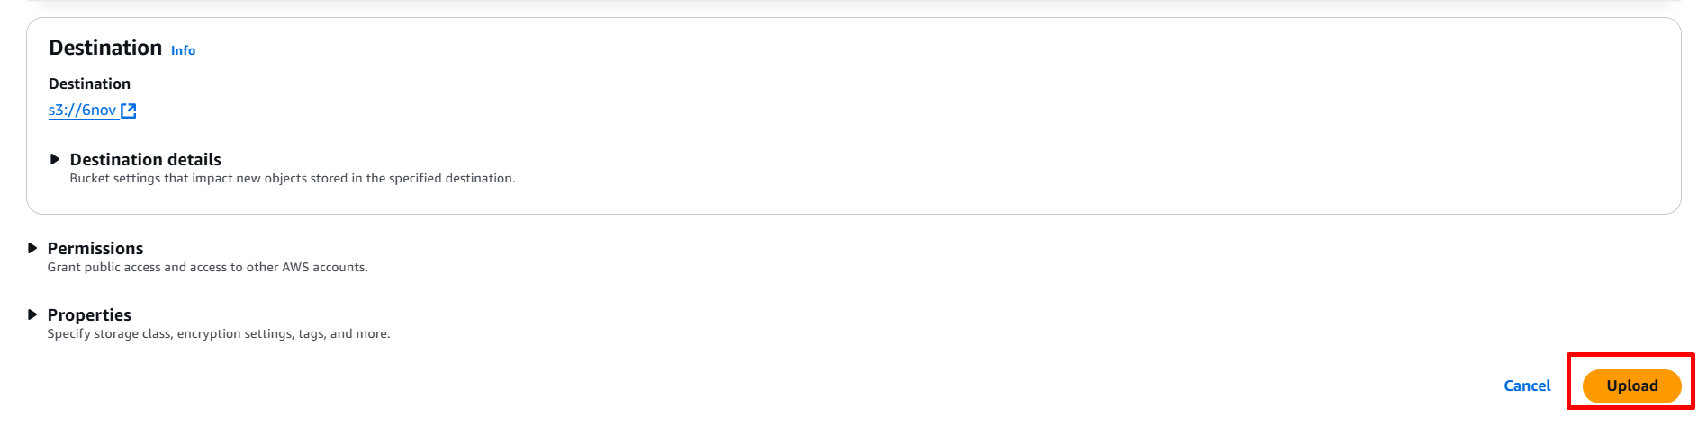

1. Files has been uploaded successfully

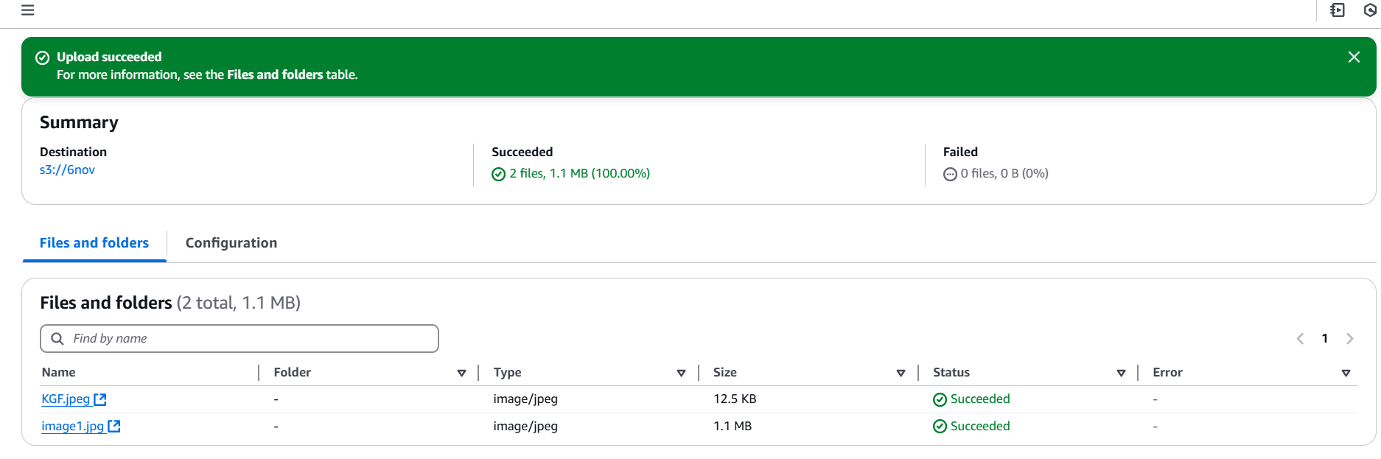

1. To list bucket 🡪 aws s3 ls

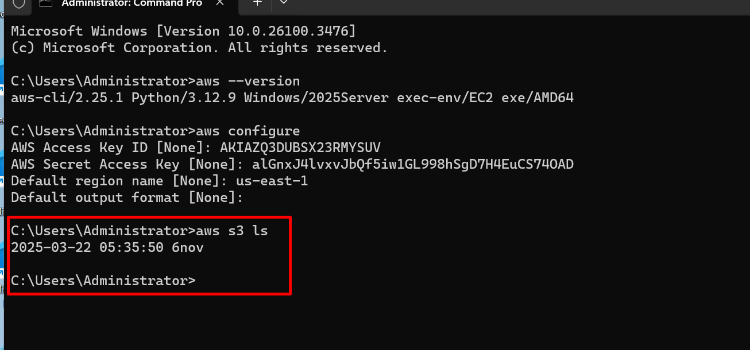

1. To download file from s3 to windows 🡪 aws s3 sync s3://<bucket-name> “C:\<path-name>

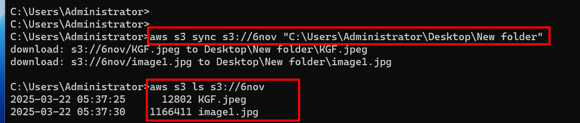

1. Download files can be seen in windows folder

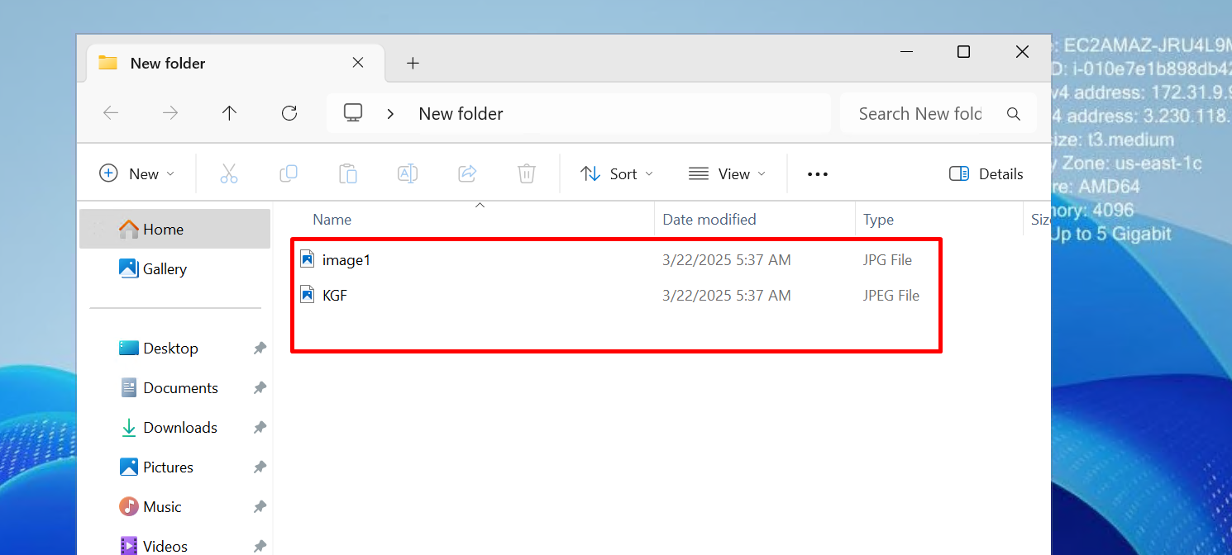

1. Files present in windows

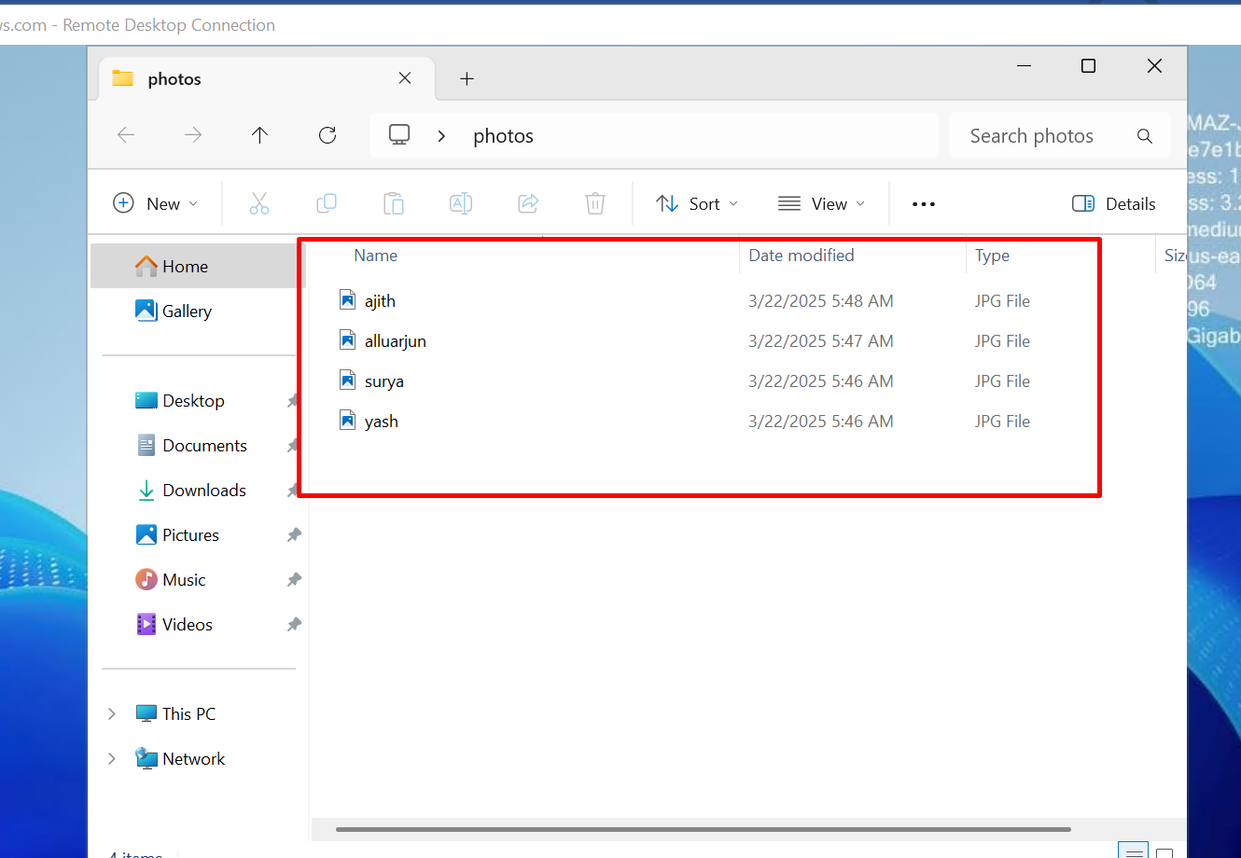

1. Files which present in s3

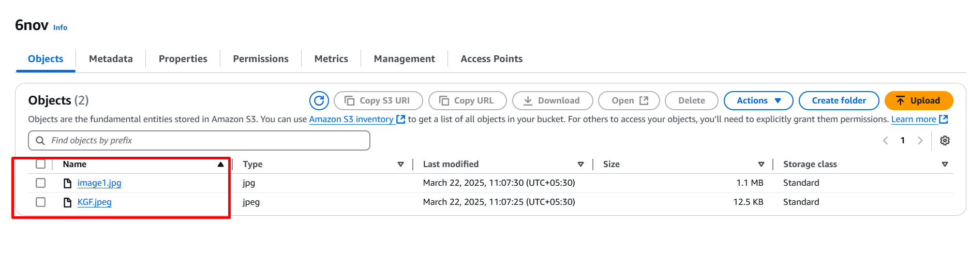

1. To upload file from windows to s3 🡪 aws s3 sync “C:\<path-name> s3://<bucket-name>

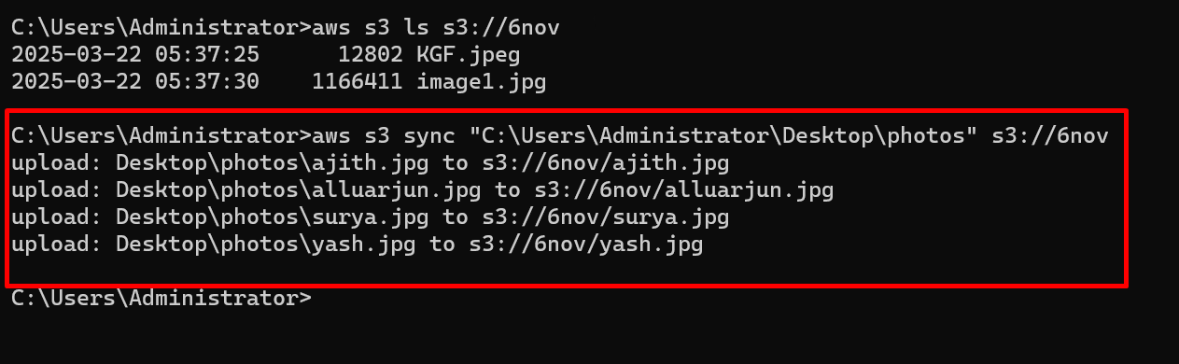

1. All files are uploaded to s3 bucket

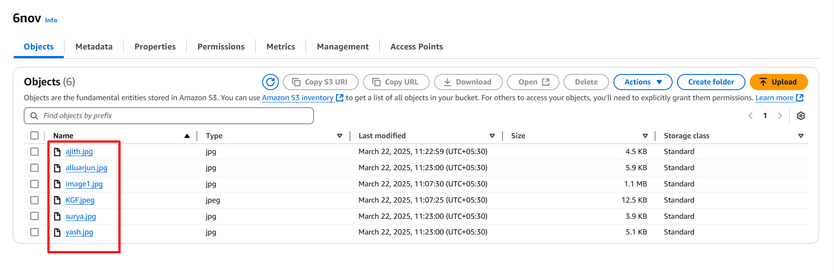

1. To delete single file

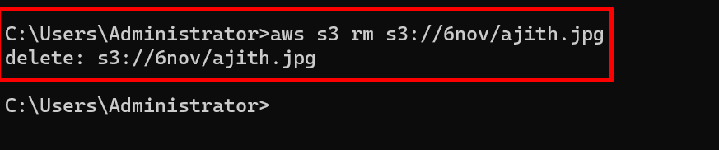

1. File as been deleted from s3

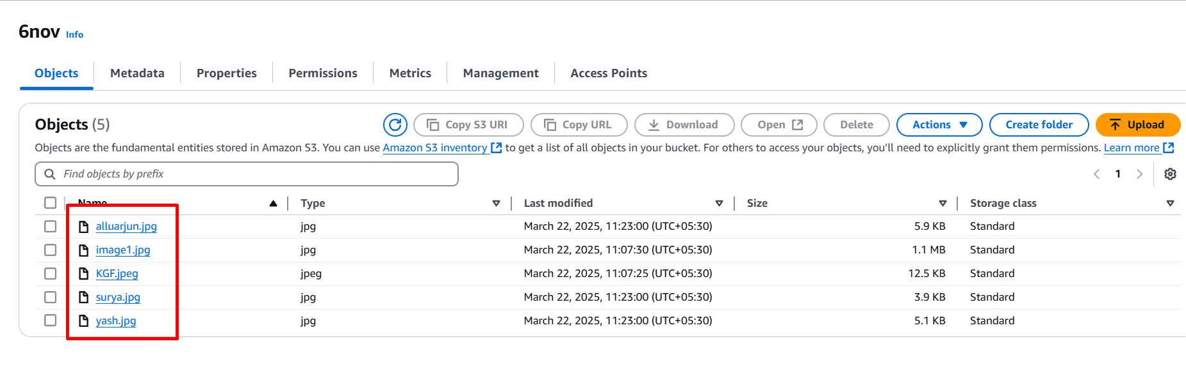

1. To delete multiple files

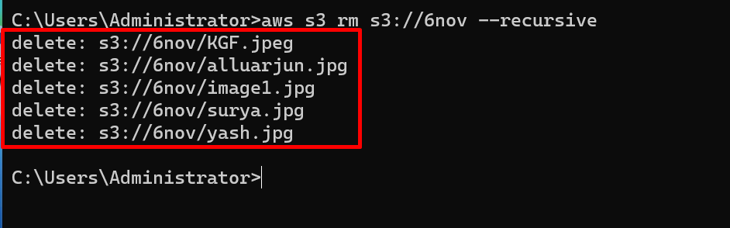

1. All files are deleted in bucket 6nov

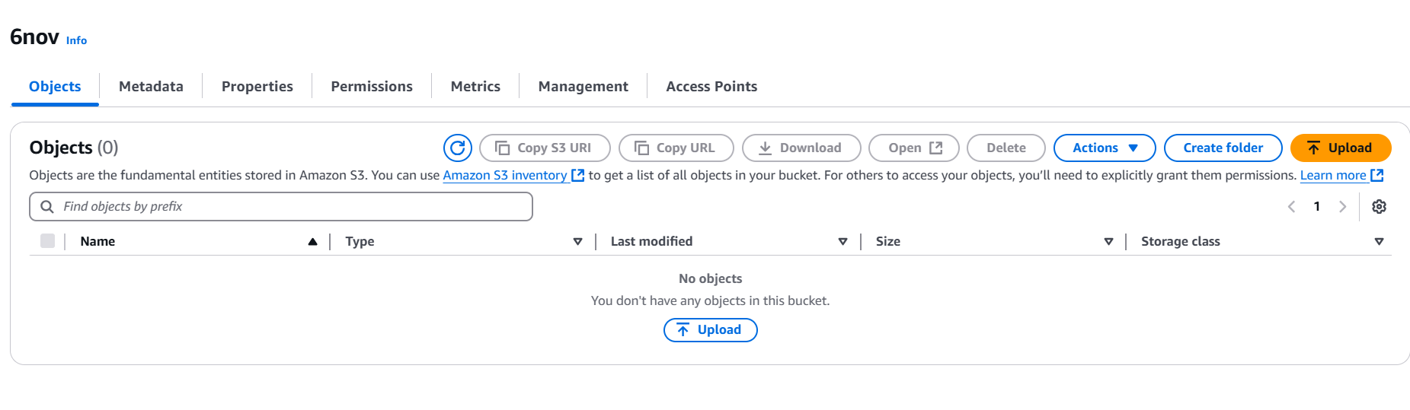

1. To upload single file from windows to s3



1. File has been Uploaded to s3 bucket

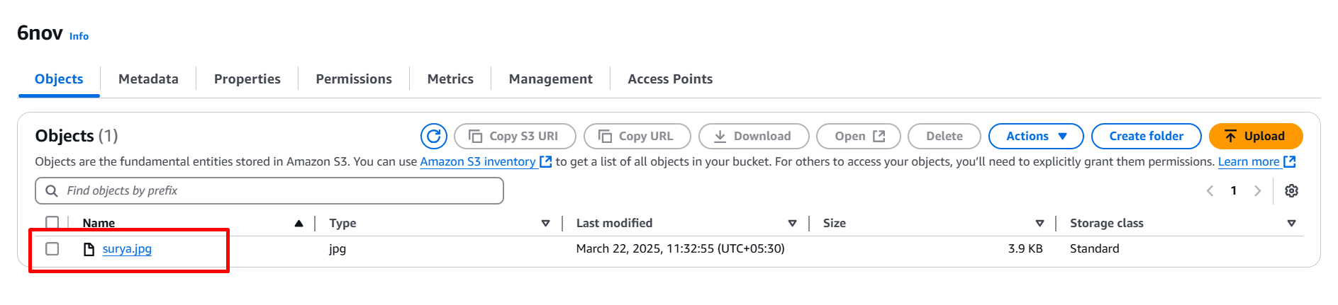

1. To list bucket 🡪 aws s3 ls

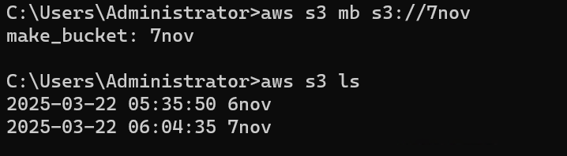

1. To copy file from bucket to bucket

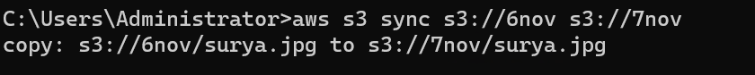

1. To upload specific files from windows to s3



1. To download specific files from s3 to windows

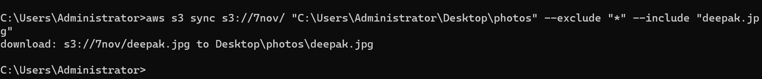

**TO DOWNLOAD TNT DRIVE IN WINDOWS**

1. Search for TNT drive

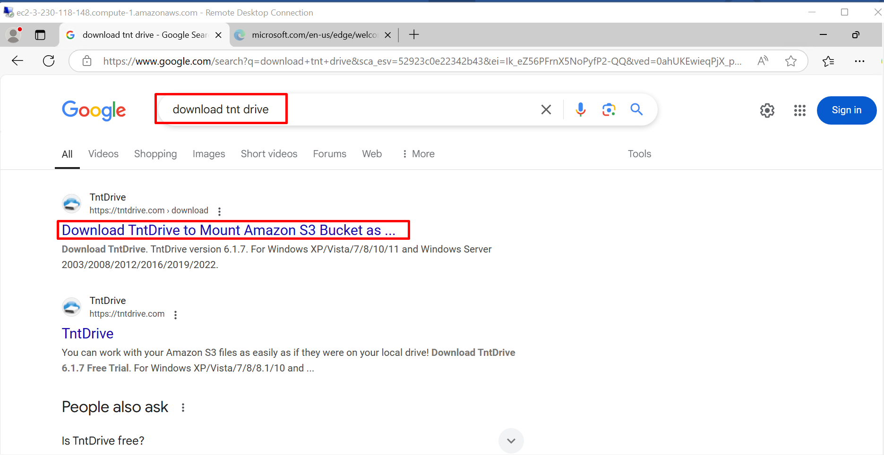

1. Download EXE Installer

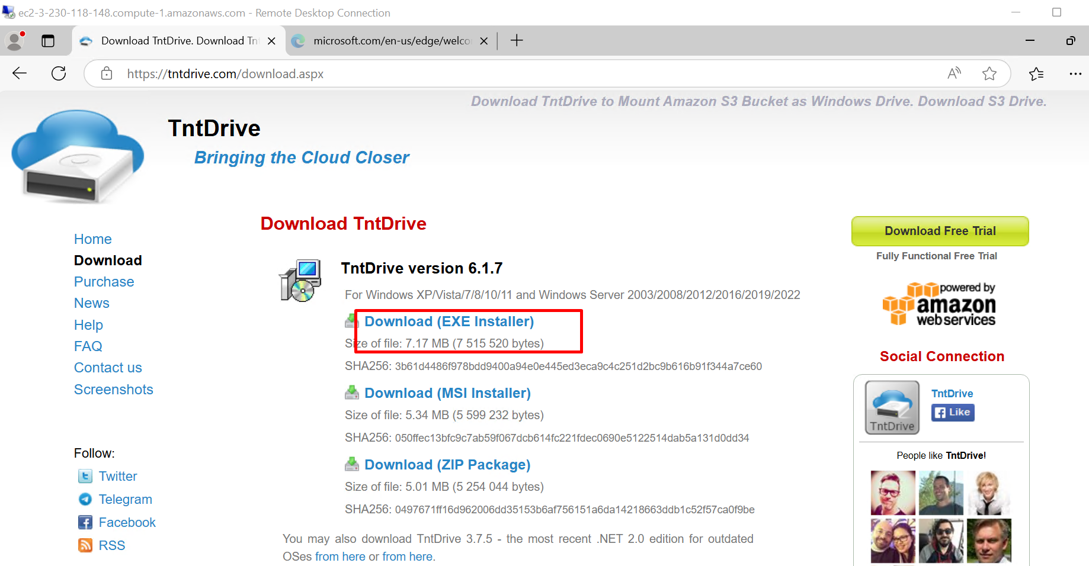

1. After downloading install software

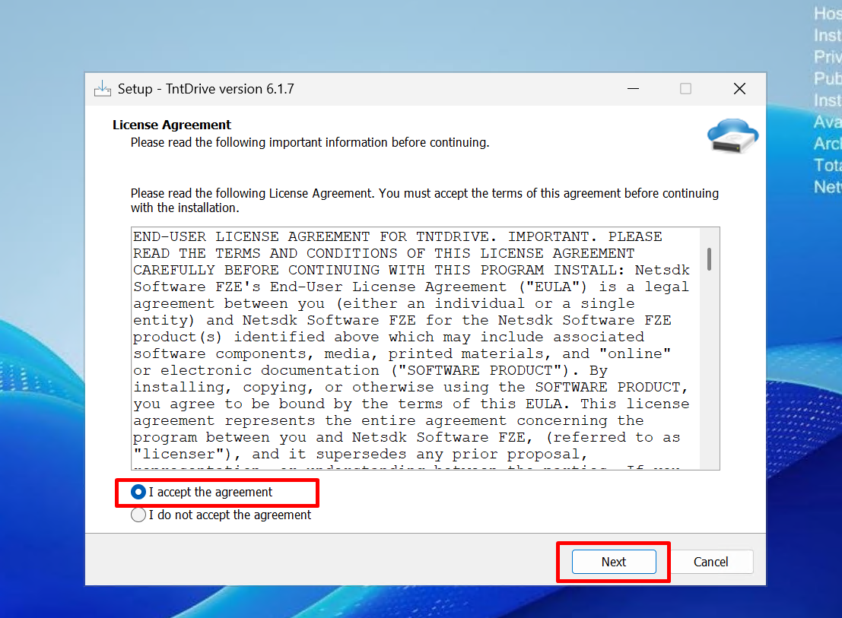

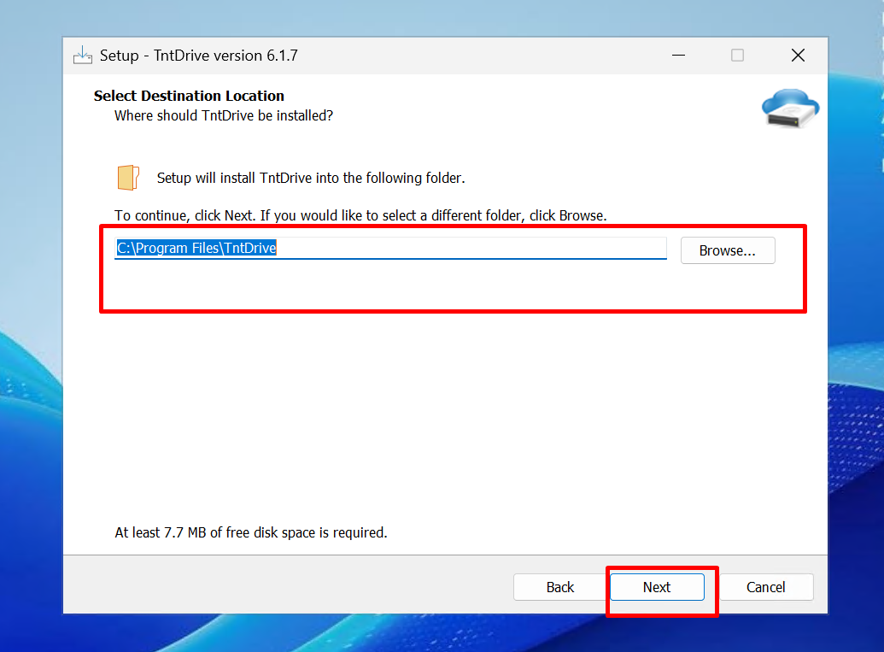

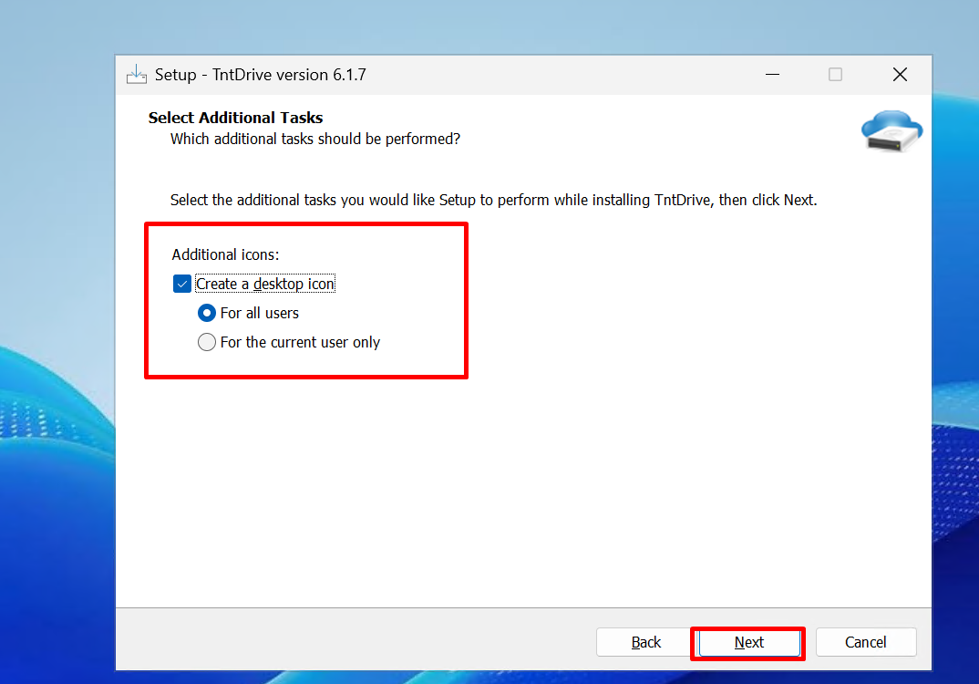

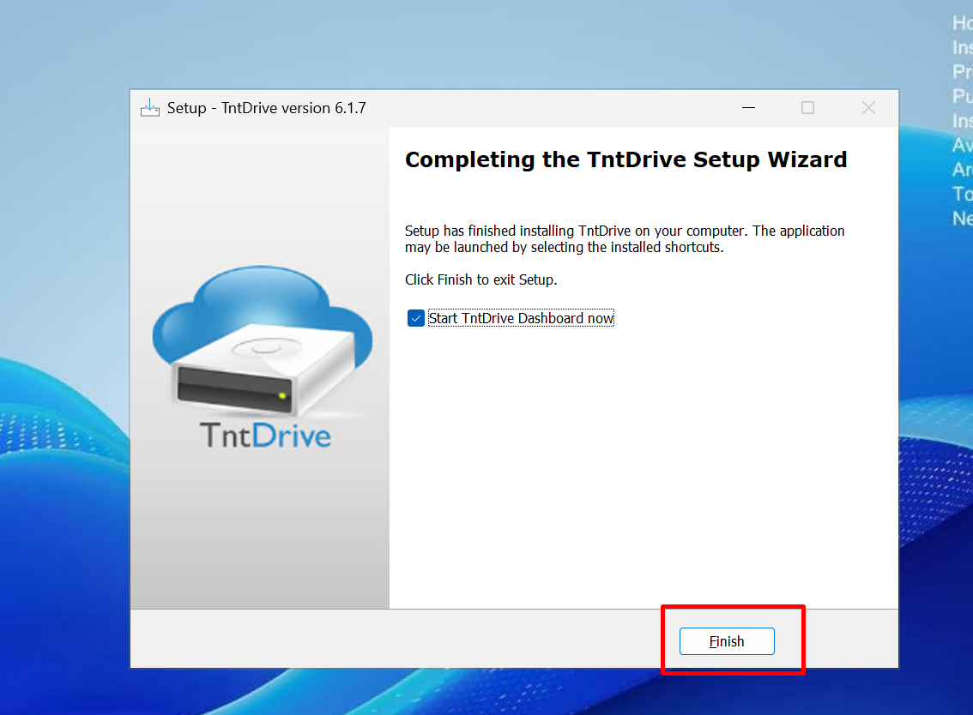

1. Open TNT drive 🡪 Add new account

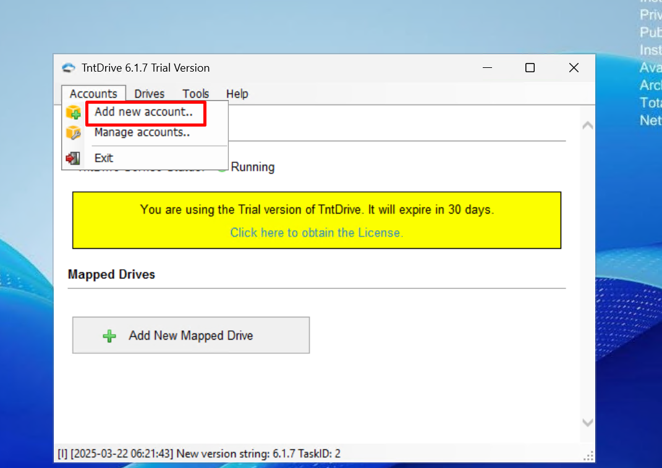

1. Enter name 🡪 Enter access key 🡪 secret access key

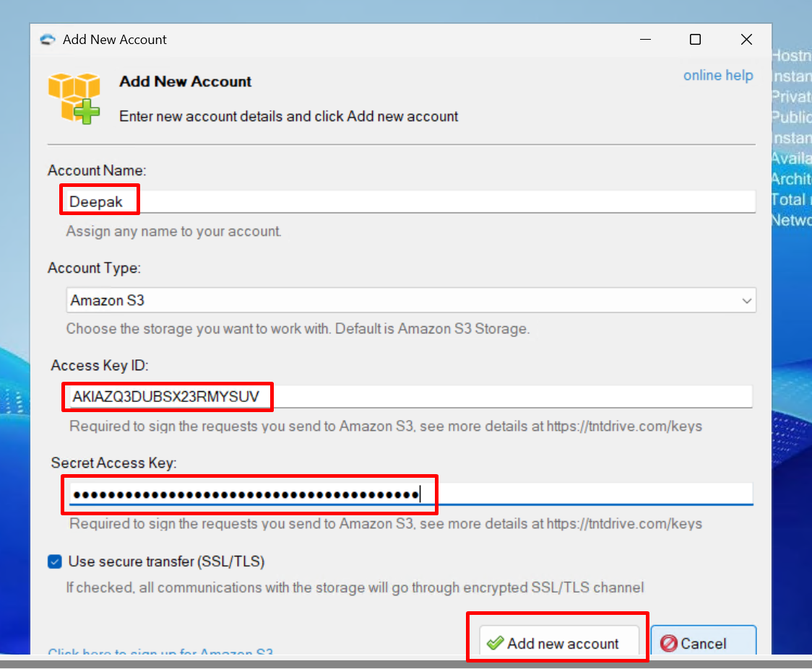

1. Click on add new mapped drive

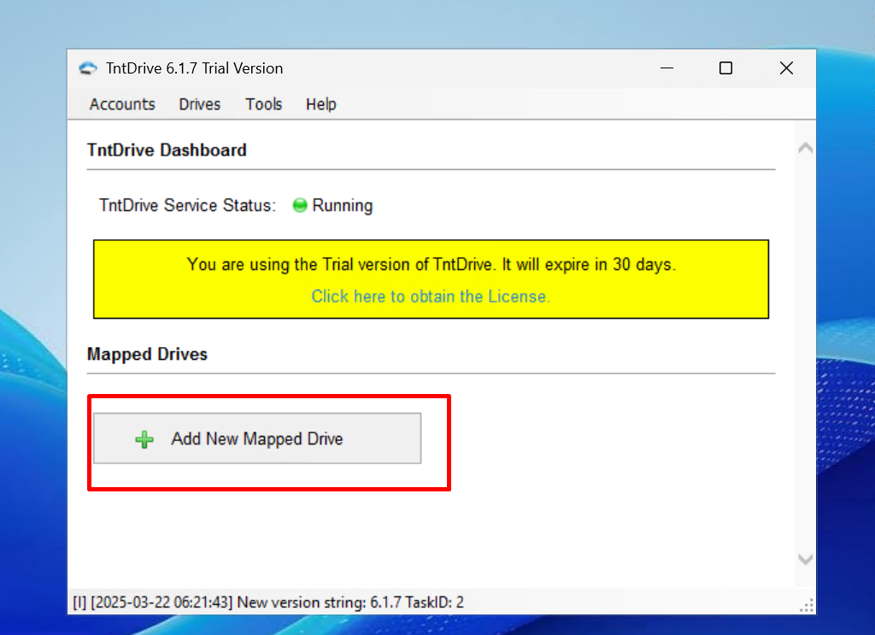

1. Select the bucket and drive letter

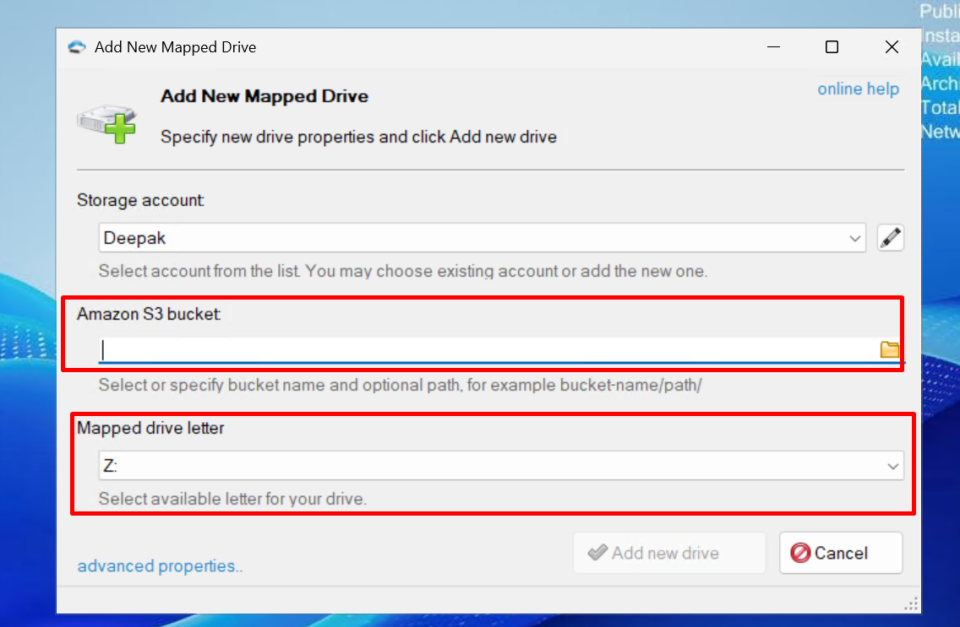

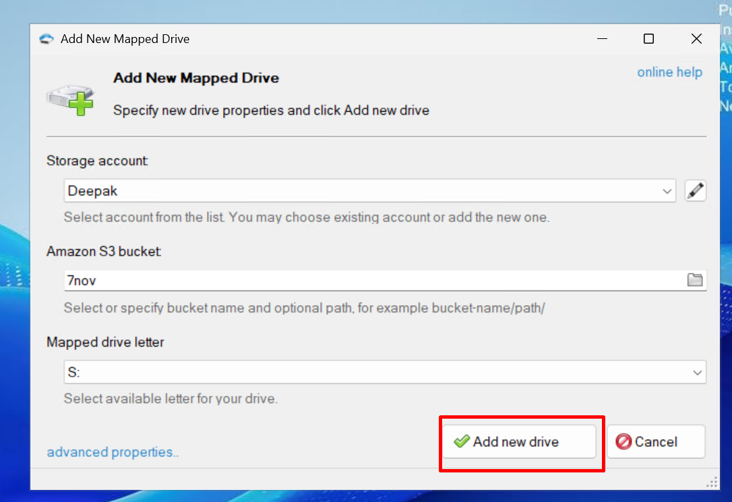

1. Then open mapped drive

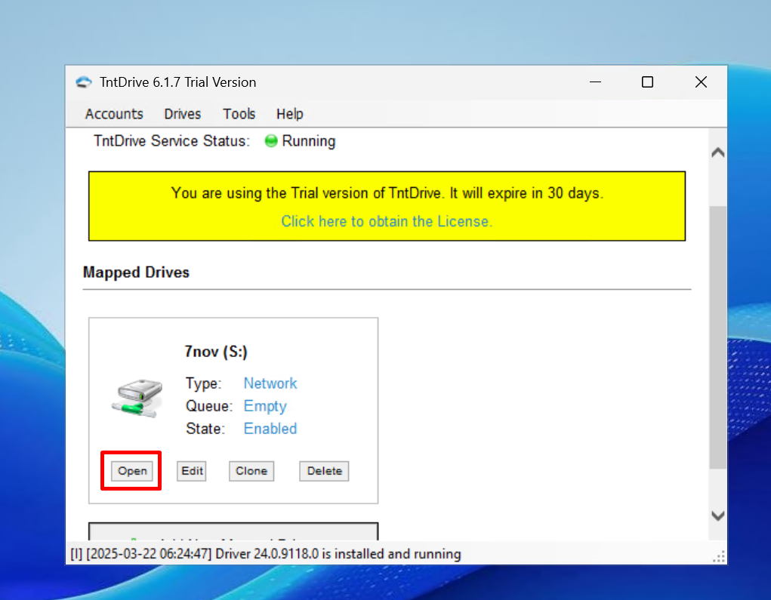

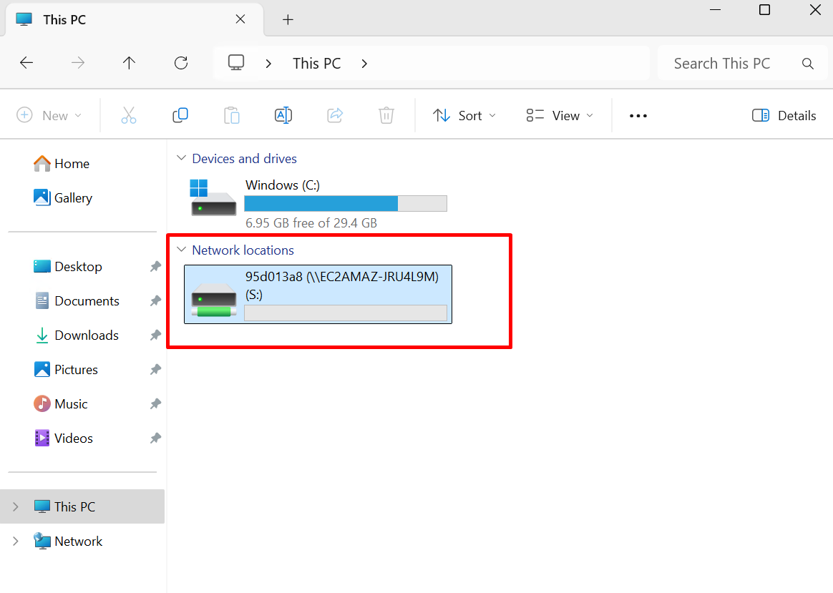

1. File are present in the bucket

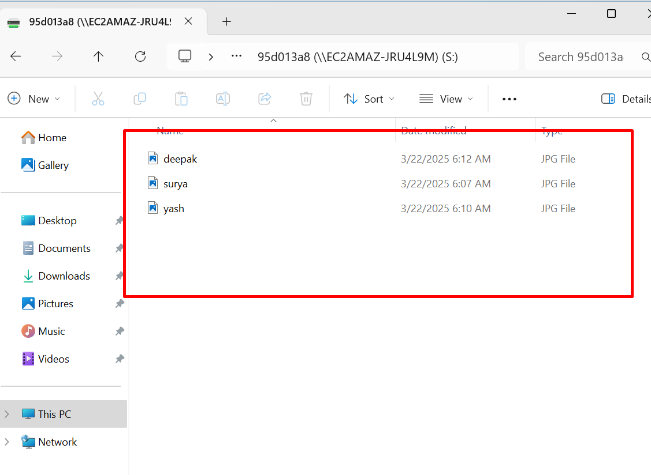

1. Copy the files from photos folder

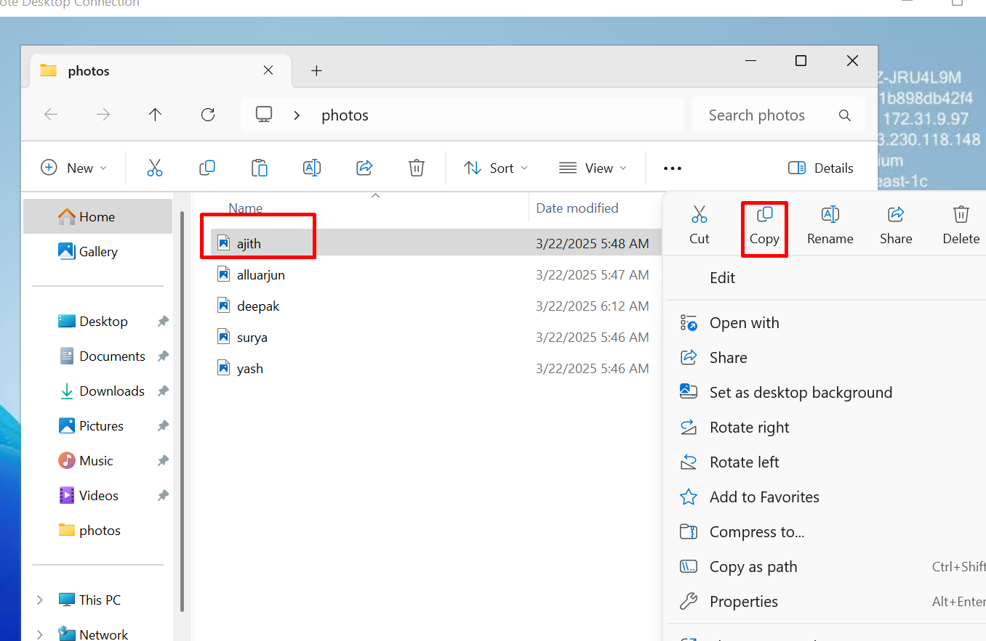

1. Paste to bucket 7nov (drive-s)

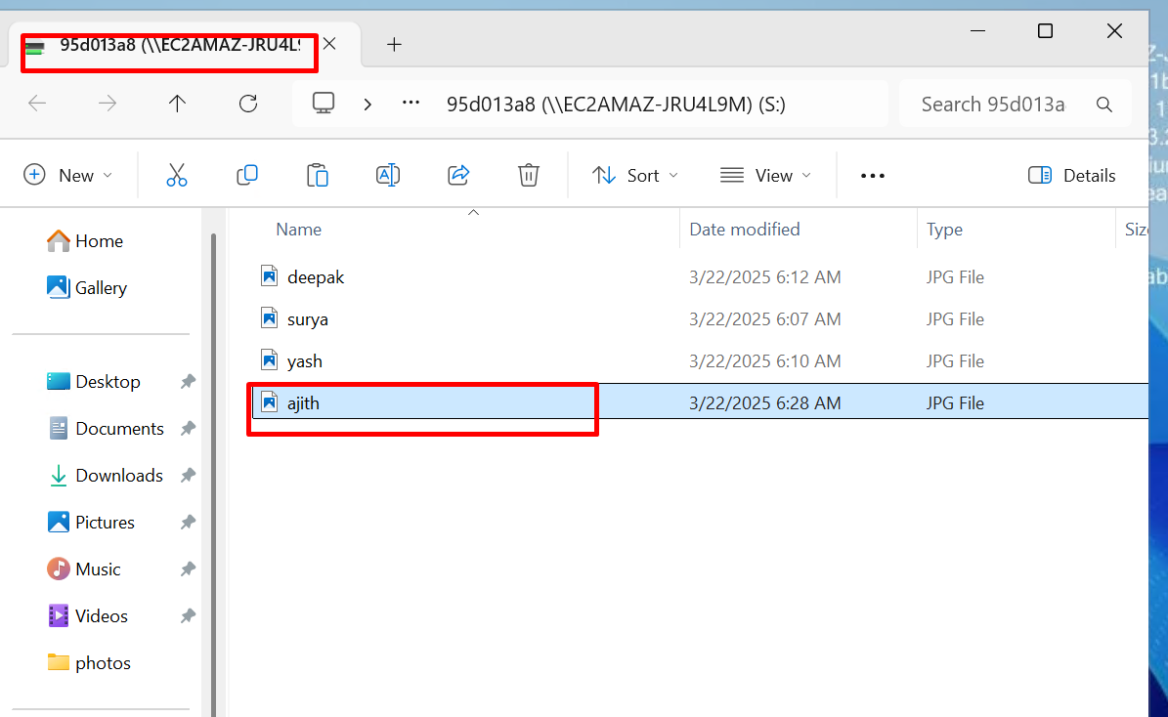

1. Copy files present inside the bucket 7nov

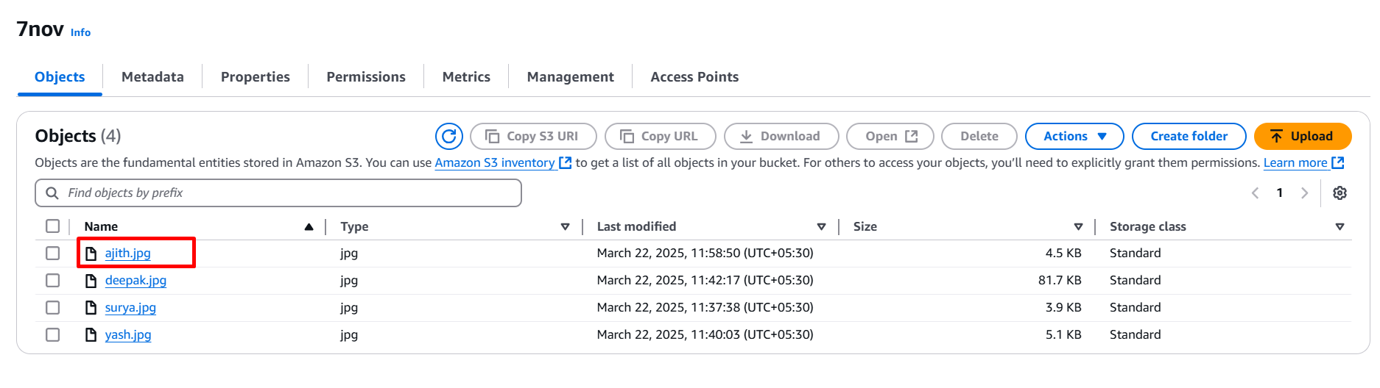

**STATIC WEB HOSTING**

1. Create new bucket 🡪 Bucket-type 🡪 bucket-name 🡪 create bucket

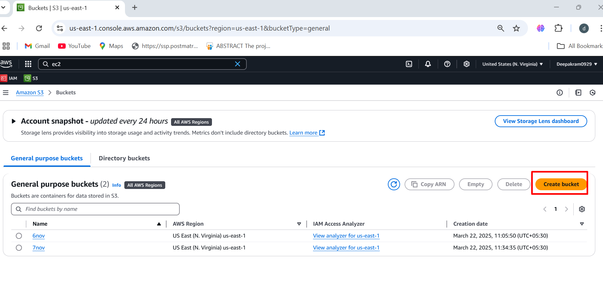

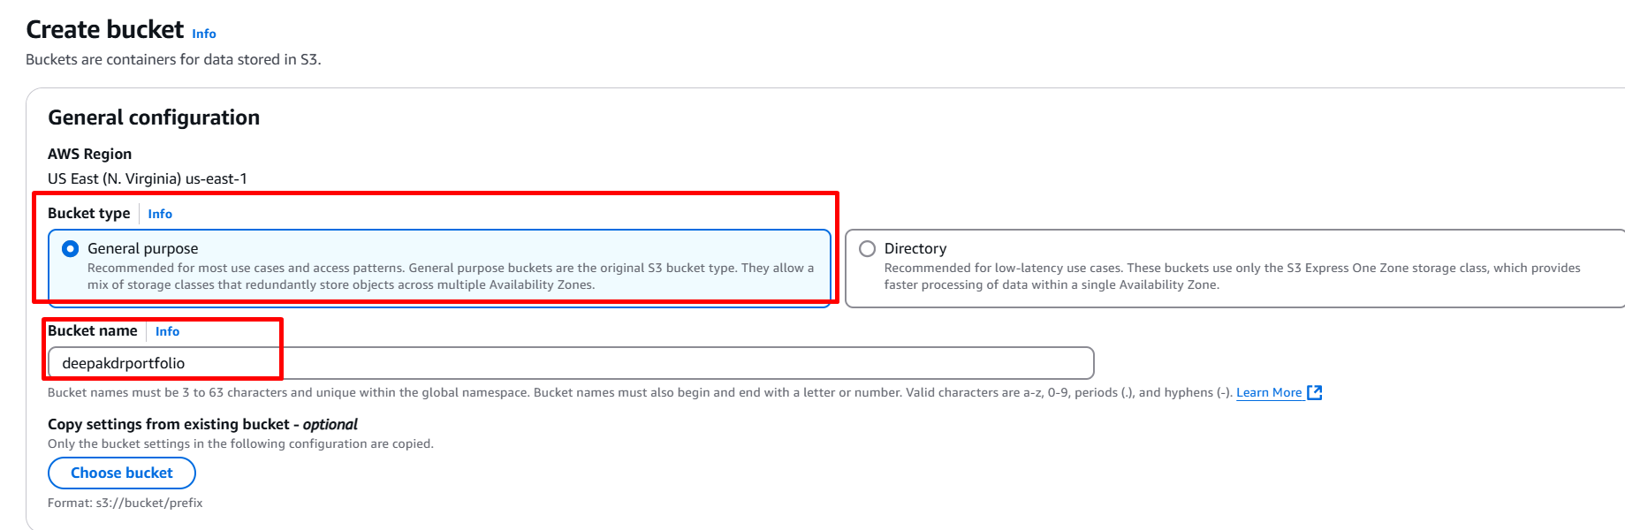

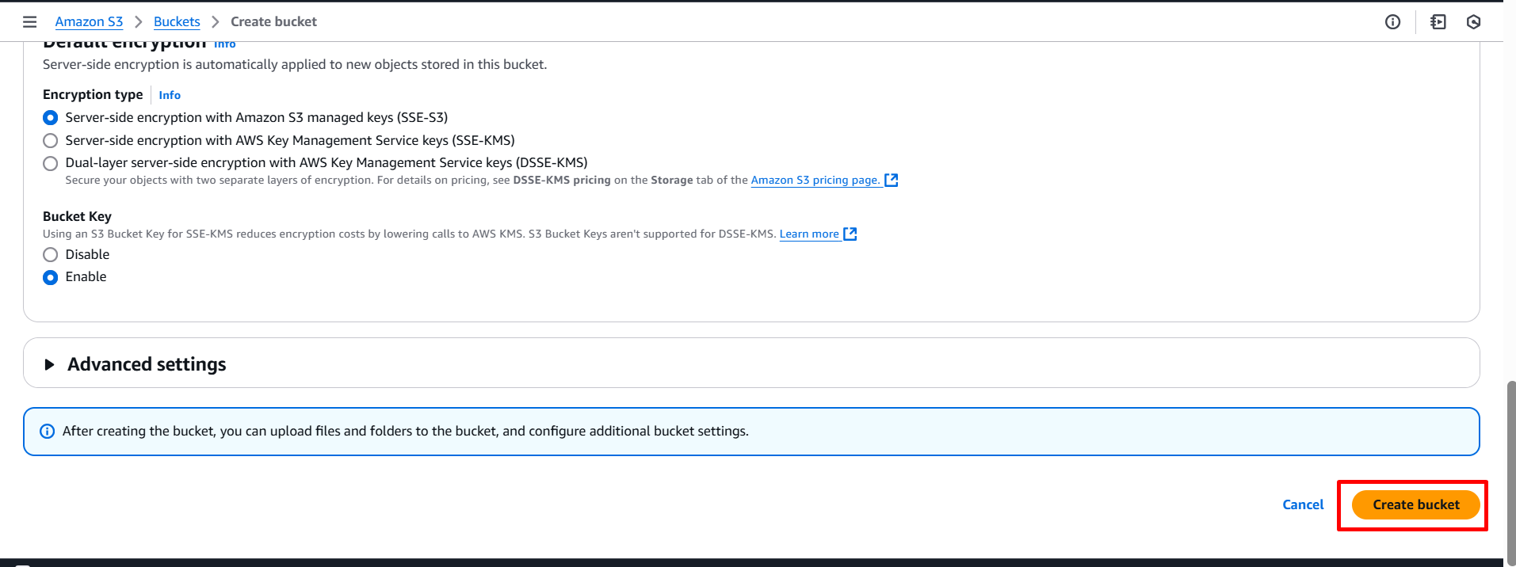

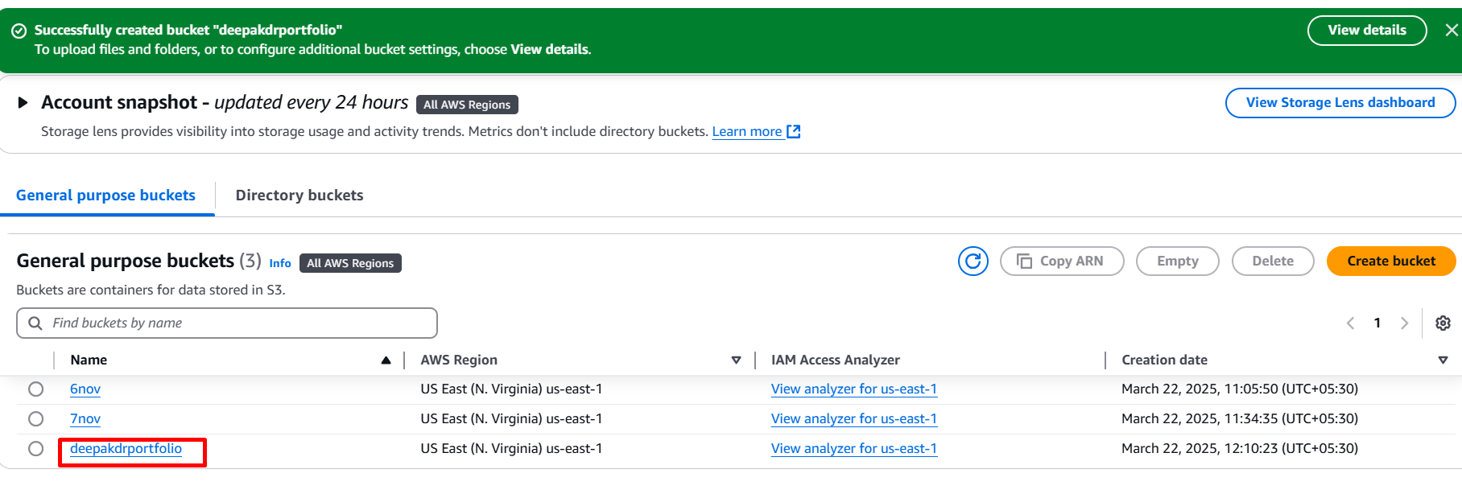

1. Enable bucket versioning 🡪 properties 🡪 bucket versioning 🡪 edit 🡪 enable

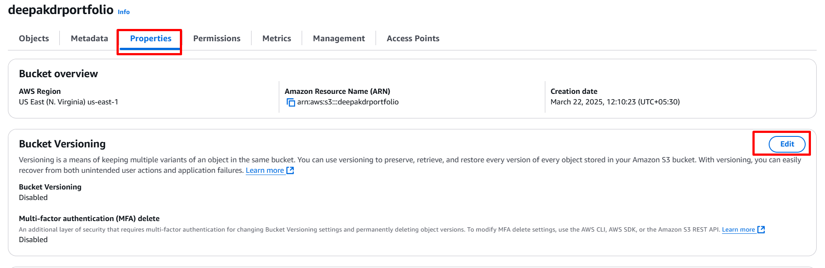

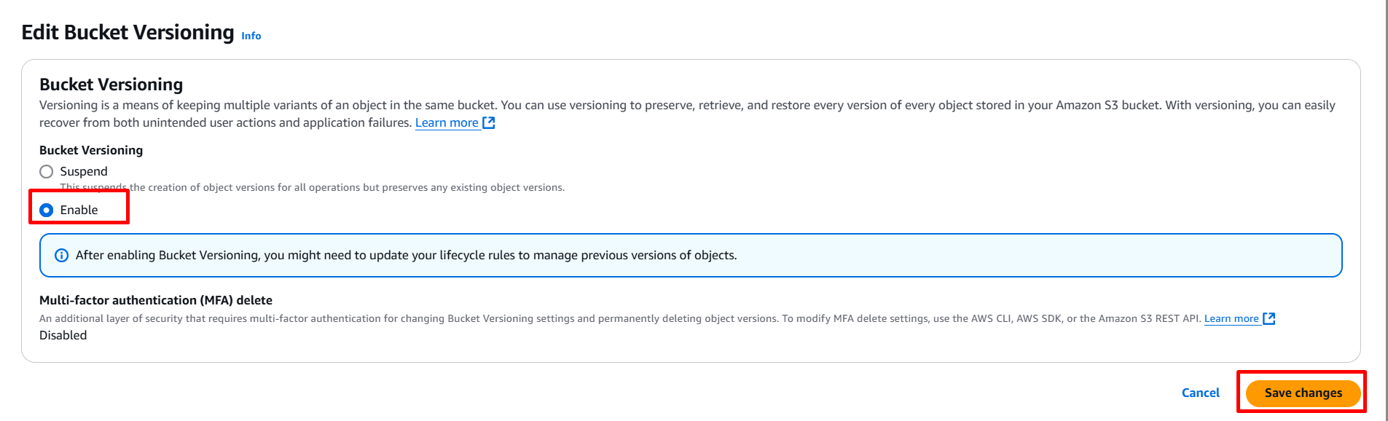

1. Enable static web hosting 🡪 Properties 🡪 static web hosting 🡪 edit 🡪 enable 🡪 index.html 🡪 save

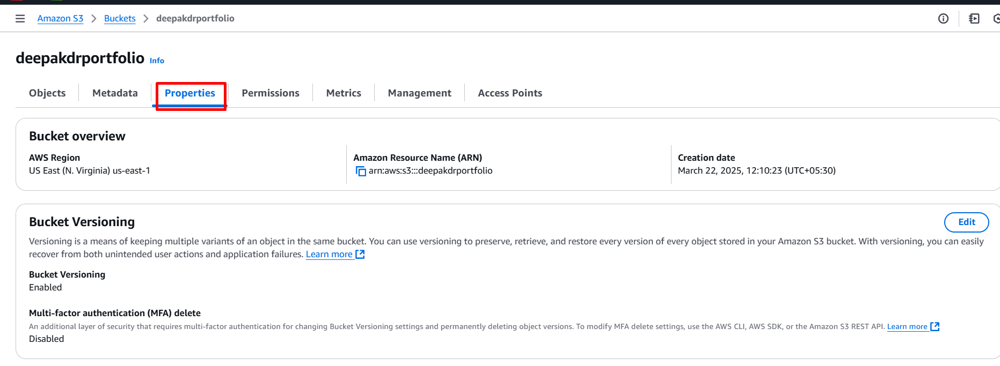

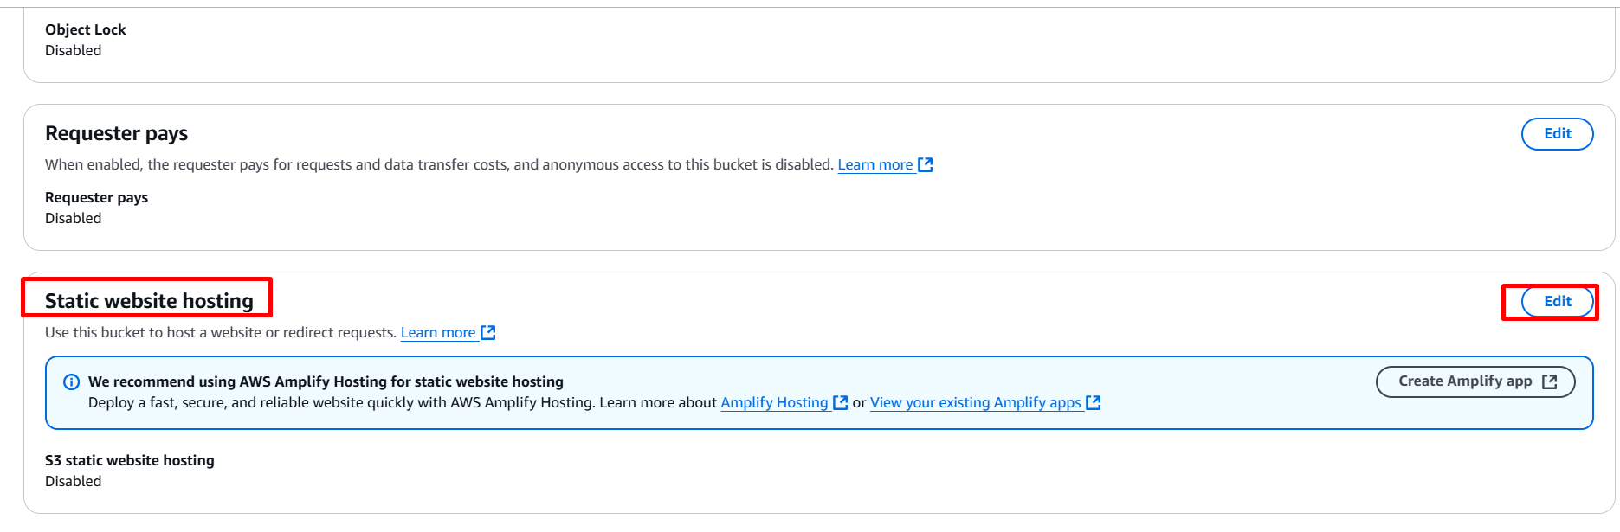

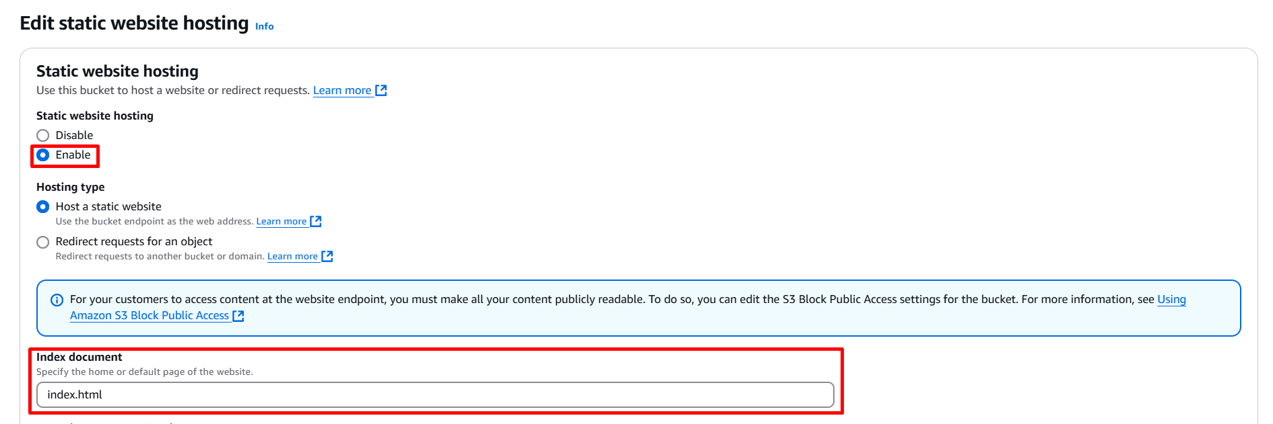

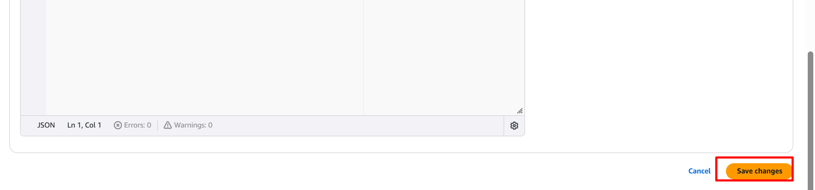

1. To unblock the public access 🡪 permissions 🡪 unblock public access 🡪 save

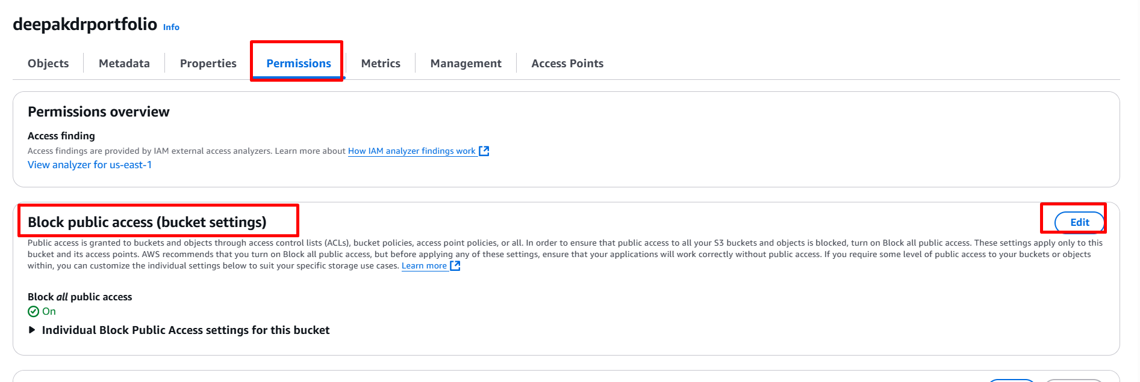

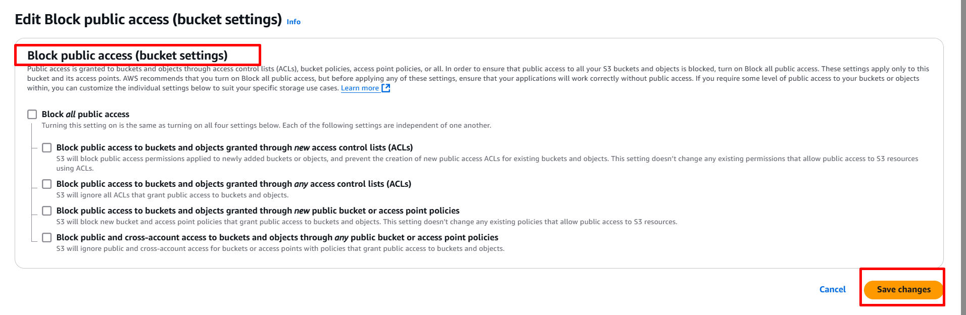

1. Generate bucket policy 🡪 Edit 🡪 generate bucket policy 🡪 S3 bucket policy 🡪 principle * 🡪 get object 🡪 bucket ARN/* 🡪add attachment 🡪 generate 🡪 copy the script 🡪 paste 🡪 save

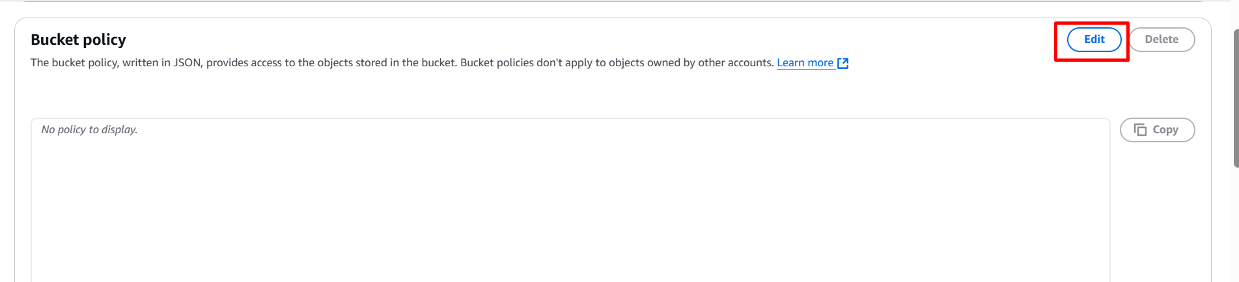

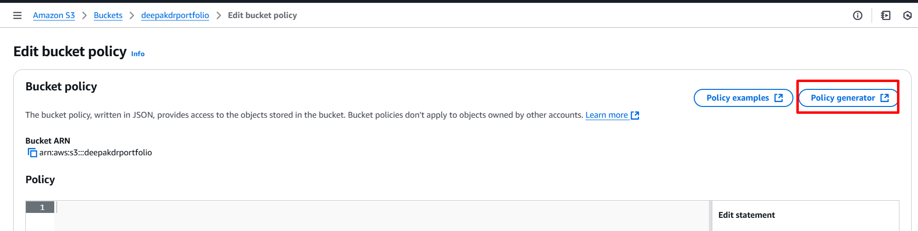

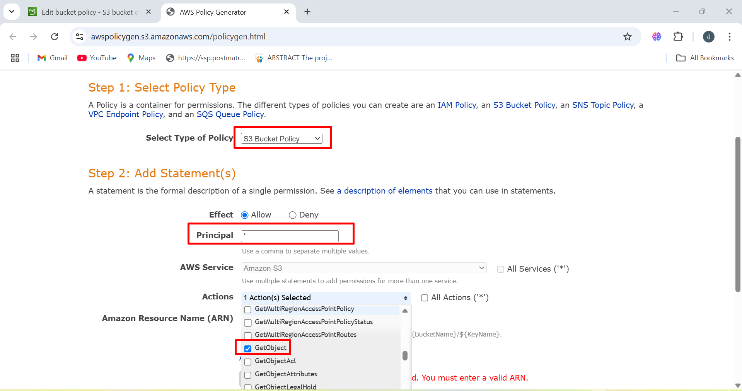

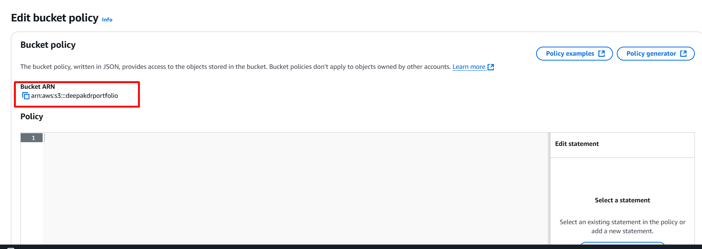

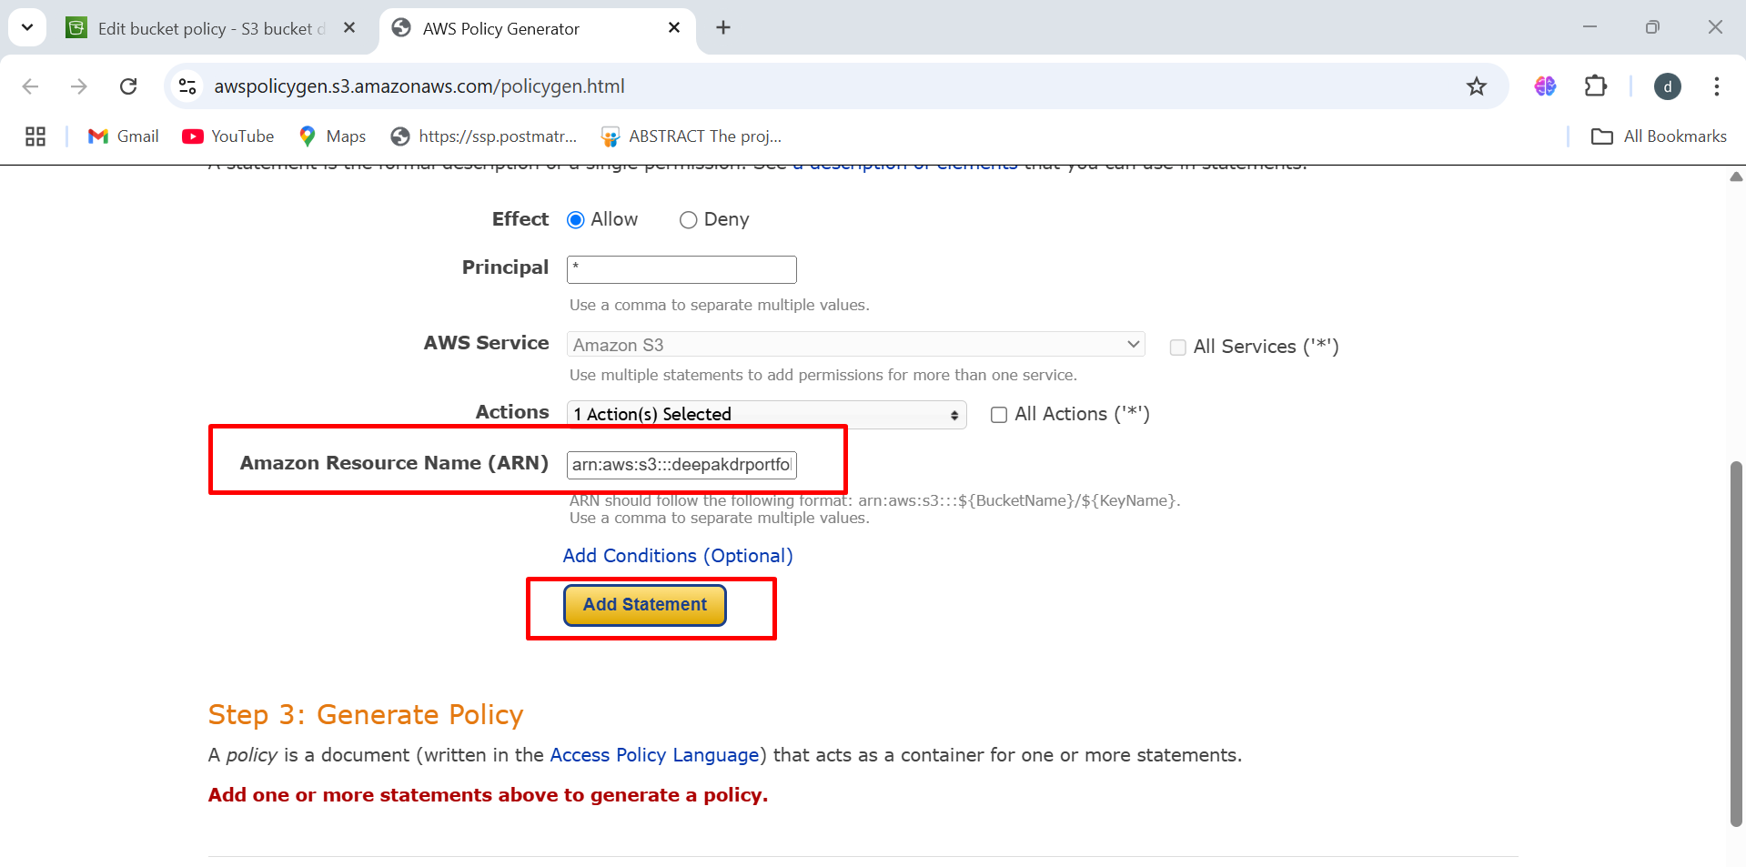

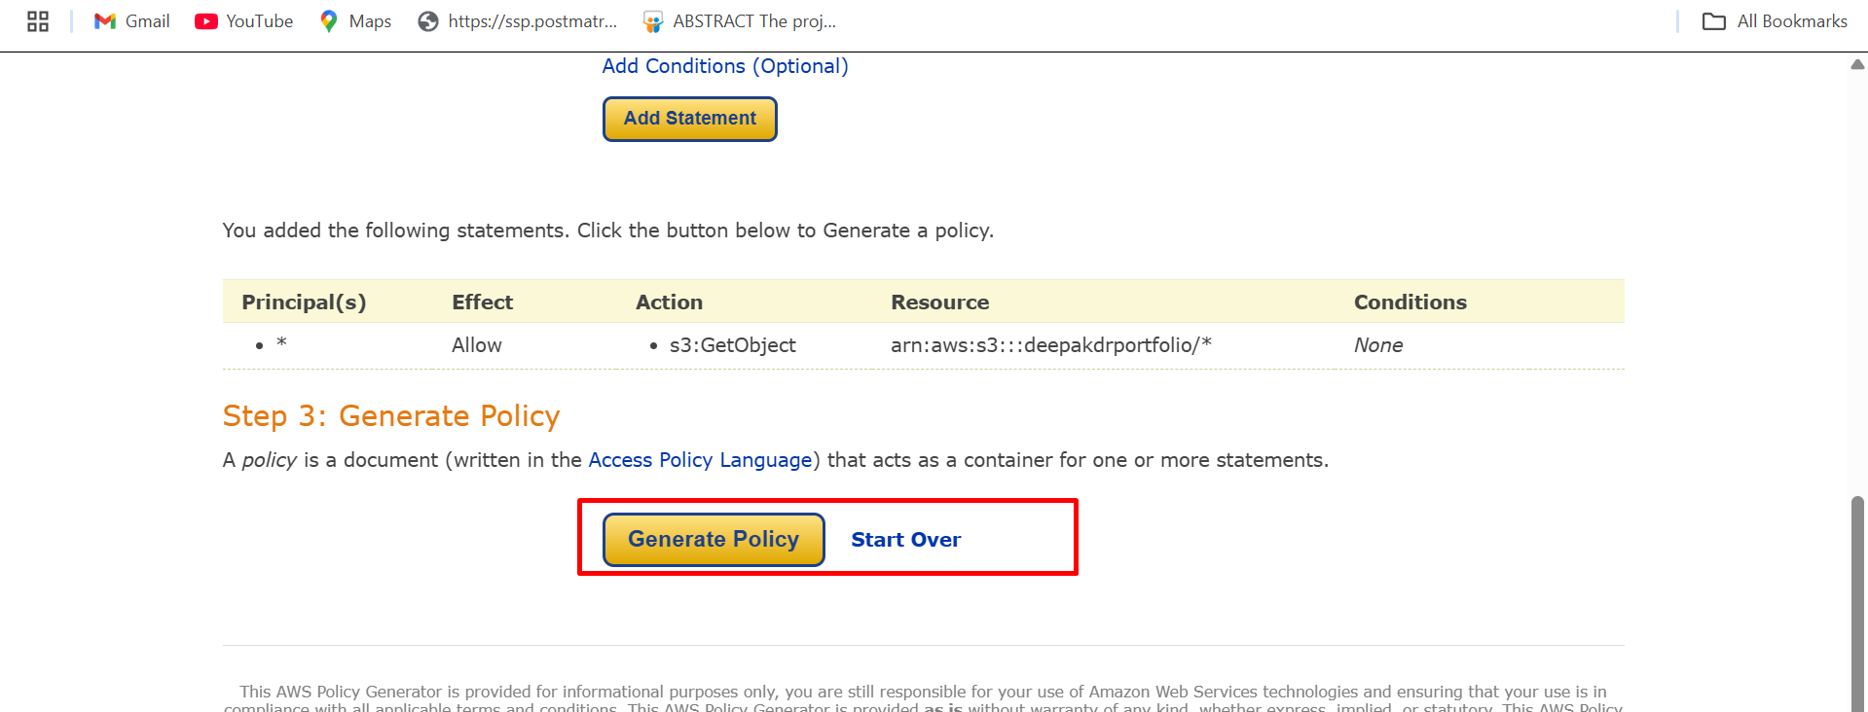

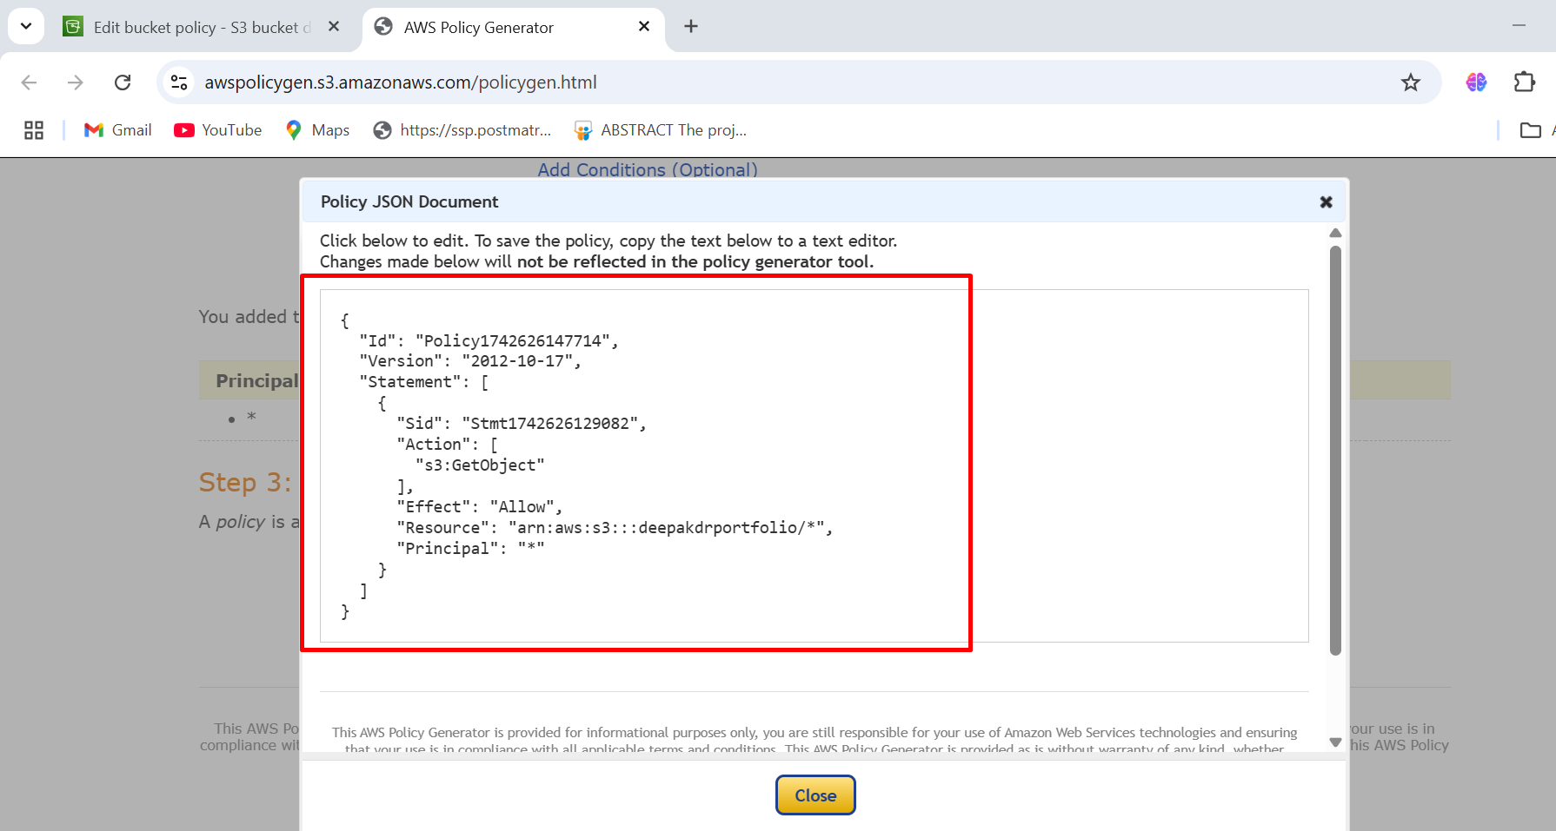

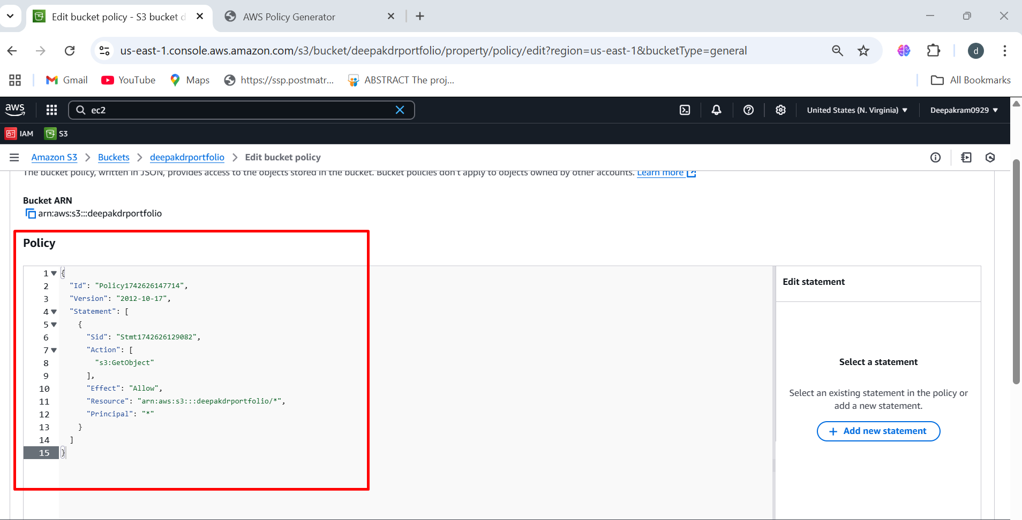

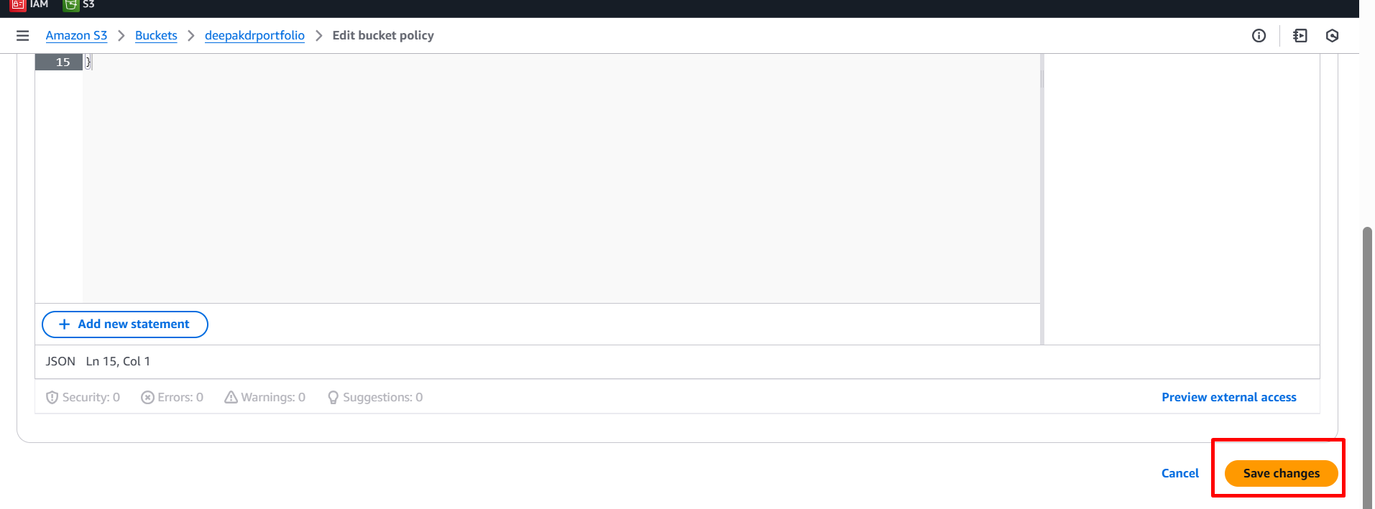

1. Upload files 🡪 add files or add folders 🡪 click on upload

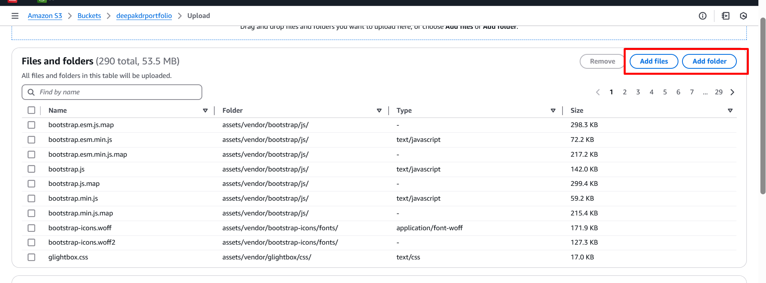

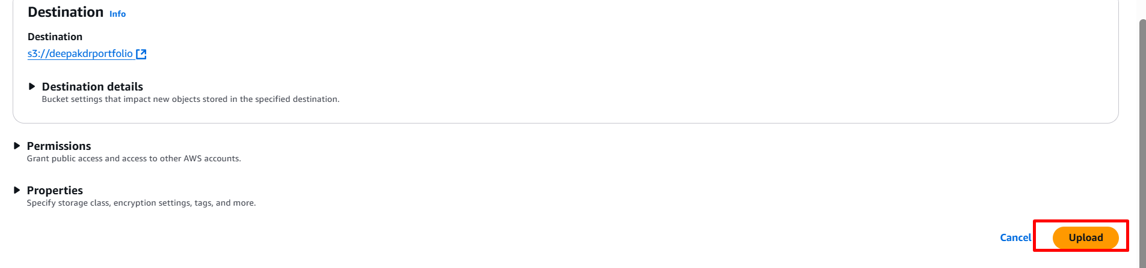

1. Uploaded objects (files) inside the bucket

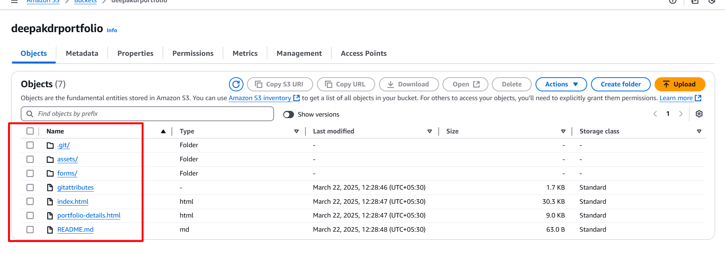

1. URL 🡪 bucket-name.s3.amazonaws.com/index.html/

